

Southern California Edison
CS Re-Platform Project

CIM-CS-03 Handle Customer Move-In/Out – Contract End
Customer Interaction Management
Business Process Design
Version 1.1

Table of Contents
1 Business Process Overview 5
1.1 Current Pain Points for Southern California Edison 5
1.2 Responsible Parties 6
1.3 Document Control 6
1.4 Terminology 7
2 Business Process Design 9
2.1 Move Out Details 9
2.1.1 Move Out Guiding Procedure 10
2.1.2 Security Deposit 17
2.1.3 Installation Plan 17
2.1.4 Budget Billing Plan 17
2.1.5 Final Bill 17
2.1.6 Owner Allocation 17
2.1.7 Program and Services 17
2.1.8 Capturing of notes 18
2.1.9 Meter Access Information 18
2.1.10 Refer Move Out to Offline Support 18
2.1.11 Added Facility 19
2.1.12 CCA/DA 19
2.1.13 Meter Replacement 19
2.1.14 Self-Certified Sensitive 20
2.1.15 Disconnection 20
2.1.16 OBF (On Bill Financing) 21
2.1.17 SB 120 – Rental Property 21
2.1.18 NEM Aggregation 21
2.1.19 Water Flow Restrictor 22
2.2 Move Out Date Change Details 22
2.2.1 Capturing of notes 24
2.2.2 Programs & Services 24
2.2.3 CCA/DA 24
2.2.4 RSS Request & Service Order 24
2.2.5 Appointment Scheduling 24
2.3 Move Out Reversal Details 25
2.3.1 RSS Request & Service Order 26
2.3.2 Capturing of notes 26
2.3.3 Programs & Services 26
2.3.4 CCA/DA 26
2.3.5 Security Deposit 26
2.3.6 Appointment Scheduling 26
2.3.7 NEM 27
2.4 Transfer Details 27
2.4.1 Paperless Billing (e-Bill) 33
2.4.2 Programs & Services 33
2.4.3 CCA 33
2.5 Process / Performance Improvement 33
2.6 Prerequisites and Inputs 33
2.7 General Assumptions 34
2.8 Business Process Hierarchy 34
2.9 Process Flows 34
2.9.1 Create Move Out 34
2.9.2 Change Move Out Date 38
2.9.3 Move Out Reversal 41
2.9.4 Transfer 43
2.10 3rd Party and SCE Legacy System Integrations 50
2.11 Data Elements 50
2.11.1 Move Out Process 50
2.11.2 Move Out Date Change 53
2.11.3 Move Out Reversal 54
2.11.4 Transfer Process 55
2.11.5 Source Systems and Data Volumes 61
2.12 Cloud for Customer (Hybris C4C) Integration 61
2.12.1 Processes 61
2.12.2 Hybris C4C Views 61
2.12.3 Activity Records 62
2.13 Exception Management Requirements 62
2.14 Process Risks and Mitigation 62
2.15 Key Performance Indicators 63
2.15.1 Key Metric Definition 63
3 Controls, Regulatory Rules, and Security 64
3.1 Security Considerations 69
3.2 Custom Program/Transaction Codes 71
3.3 Custom Table/Transaction Codes 71
4 Technical Considerations 72
4.1 RICEF-W Assessment 72
4.1.1 Reports 72
4.1.2 Interfaces 72
4.1.3 Conversion 72
4.1.4 Enhancements 73
4.1.5 Forms 74
4.1.6 Workflows 75
4.2 IDEX Considerations 75
4.3 Production System Cut-over Considerations 75
4.4 Other Considerations 75
5 Change Management 76
5.1 Change Impacts 76
6 Requirements 81
7. Ticket 82
8. Appendix 83

This page intentionally left blank

Business Process Overview
There are two processes that will be mentioned in this document, they are Move-Out and Transfer process.
The Handle Customer Move-Out - Contract End will define how a Business Partner's (BP) contract will be ended within SCE SAP environment.
The Move-Out process contains the processes that manage all Move Out related activities for a BP that are executed within Hybris C4C and S/4HANA and can be extended to SCE.COM and IVR. The Contract is an agreement between SCE and the BP for the supply of service at a specific location at a specified point in time.
The Manage Transfer process will define how service for the BP will be ended at one location and service will be activated at another location within SCE SAP environment. These processes will also integrate with the process for the creation of field work requests and remote disconnect, refer to the BPD DF-WM-02 - Handle Field Orders - Manage Field Orders and DF-WM-03 - Handle Remote Orders - Manage Remote Orders document for additional details.
Overall, the move-out manages the following processes:
- New Contract, or Move-In – discussed in BPD document CIM-CS-02 - Handle Customer Move-in/Out - Contract New
- Move-In Adjustment – discussed in BPD document CIM-CS-02 - Handle Customer Move-in/Out - Contract New
- Move-In Reversal – discussed in BPD document CIM-CS-02 - Handle Customer Move-in/Out - Contract New
- End Contract, or Move-Out – mentioned within this document
- Move-Out Adjustment – mentioned within this document
- Move-Out Reversal – mentioned within this document
- Transfer – mentioned within this document
Not all move out scenarios are triggered through Hybris C4C, other scenarios include:
- SCE.COM: Move Out can be done by a BP via SCE.COM. Refer to BPD document CIM-CS-10 Manage Customer Self-Service for more details.
- Dunning triggered Move Out: Dunning Move Out will be automatically generated by the collections process once a customer’s service has been dunning disconnected after 14 days. This process is defined in the BPD document CC-FI-04 – Manage Collection (Dunning) – Manage Credit and Collections.
- IVR: Move Out requested from IVR will have integration with S/4HANA and be able to perform a Move Out. Refer to BPD document CIM-CS-13 - Manage Inbound Telephone Call – IVR for more information.
Finally, all utility specific functions of the S/4HANA landscape, in concert with the Hybris C4C components referred to in this document as the SAP Customer Relationship and Billing solution, or simply CRB.

Current Pain Points for Southern California Edison
- Forwarding Addresses – Currently adding foreign forwarding addresses isn’t easy for agents and requires back-office intervention
- In the case of force out, the forwarding address is not captured from the current resident
- Online Move Out for non-residential BP generates a manual back office process
- Tracking non-residential orders is a manual process
- Exception queue is worked first in first out and changes made to orders that are still pending in the queue cannot be worked until the order is picked by queue
- Visibility of Added facilities is lost between move out and move in if the new customer does not sign up (assumption agreement) for the Added Facility
- Visibility of streetlight transfer is lost between Move Out and Move In if the new customer does not sign up for the streetlight.
- If a move-out is reversed today, the programs the customer is enrolled in are not automatically re-established causing a lot of manual research and effort to put them back on the programs. There are also many instances where employee didn’t address the program re-enrollment and subsequently the customer calls about the issue.
- Today, our Energy Advisors have limited ability/permission to process move-out reversal/adjustment. They must send the request to RSO which can delay the process for the customer.
- Non-residential customers cannot complete a move out on SCE.com
- When a CCA customer moves out, the final bill from SCE may be missing the final charges from the CCA. When the CCA charges are received by SCE, a second final bill is sent to the customer for the CCA charges. This is a timing issue as we need to receive the final charges from the CCA before sending the final bill to the customer. It would be best to have only 1 final bill sent to the customer.

Responsible Parties
Contact | Contact Person
Southern California Edison Business Process Owner | Janet Covington
Southern California Edison Lead | Christine Evans
HCL Functional Lead | Adrian Halim
Solution Architect | Pedro Costa
Front Office Lead | Christine Evans
Subject Matter Experts | Deborah Tillman, Araceli Perez, , Scott Hirth, Aida Diaz, Christina Albrecht
Key User Group | CCC, BCD, RSO, OLS

Document Control
Version | Description of Change | Date | Author
0.1 | Creation of Initial Version | 01/29/2018 | Tuan Howe Yap
0.2 | Reviewed by HCL CIM Lead | 02/01/2018 | Adrianus Halim
0.3 | Update based on review and new addition | 02/07/2018 | Tuan Howe Yap
0.4 | Update based on Traci review and added process flow for Transfer | 02/10/2018 | Tuan Howe Yap
0.5 | Update based on BCD and Latha review | 02/15/2018 | Tuan Howe Yap
0.6 | Business Feedback | 02/16/2018 | Cari Young
0.7 | Updated process flow diagrams & update based on review feedback | 02/17/2018 | Tuan Howe Yap
0.8 | Update based on review feedback | 02/20/2018 | Tuan Howe Yap
0.9 | Update based on walkthrough feedback | 02/22/2018 | Tuan Howe Yap
0.10 | Update based on business feedback | 02/27/2018 | Tuan Howe Yap
0.11 | Update based on business feedback | 03/16/2018 | Tuan Howe Yap
0.12 | Update based on business feedback | 03/21/2018 | Tuan Howe Yap
1.1 | Added Control tag in process flow | 05/03/2018 | Tuan Howe Yap

Terminology
Term/Acronym | Definition and SAP Equivalent (if applicable)
APSE | Accelerated (or Axon) Project Support Environment
BBP | Budget Billing Plan, equivalent to Level Pay Plans in SCE CSS
BDEX | SAP add-on functionality to support the processing of BPEM Cases
Billing Cycle | Is a group of contracts to be billed together via date-driven or regional criteria, it controls the billing cycle and is linked to the Meter Reading Unit. SAP equivalent term is the Portion.
Billing Document | A document that outlines the charges incurred for energy consumption for a specific contract. During the process of Billing, a billing document is generated for each contract on a contract account.
BMD | Business Master Data. The customer information which includes personal details, payment terms, dunning levels, billing rates and rate categories. The business master data objects are Business Partner, Business Agreement/Contract Account and Contract.
BP | Business Partner
BPD | Business Process Design (or Document)
BPEM | Business Process Exception Management
BWR | Basic Work Request. SAP equivalent is BPEM.
CA | Contract Account
CCRP | Customer Champion Recognition Program
Channel | Data object in SAP that holds the interval data. Intervals can be kwh, price, factor, etc. SAP equivalent is Profile.
CIMS | Customer Information Management System in SharePoint
Clarification | A list of payments that could not be processed and require additional work in order to be posted.
Connection Object | Link between installation and postal regional structure. Usually a building, but can also be a piece of property or other facility, such as a fountain or construction site. The connection object corresponds to the functional location in plant maintenance (PM).
Customer | Any entity with a relationship with SCE. This term is usually used in reference to customers (both individuals and organizations) This can include employees and third-party suppliers (banks and payment partners). SAP Equivalent is Business Partner (BP)
CRB | SAP Customer Relationship & Billing system. This is what is being implemented with the CSRP program.
CSR | Customer Service Representative
CVD | Customer Verification Department
EAM | SAP Enterprise Asset Management
ERP | SAP Enterprise Resource Planning
IMG | SAP Implementation Guide - where configuration is performed
Level Pay Plans | SAP equivalent term is Budget Billing. Budget Billing allows customers to pay regular equal amounts over a yearly period.
MDT | Master Data Template, is used to create Contract and Move Out Document in S/4HANA
NMS | Network Management System
PoD | Point of Delivery, an object in Installation
RSS | Remote Service Switch
SCE | Southern California Edison
SPI | Same Party In
Summary Billing | Standard SAP functionality that enables the invoicing of multiple Contract Accounts under one Parent Contract Account (Consolidated Summary Billing). SAP equivalent is Collective Billing.
S/4HANA | SAP ERP Central Component (SAP) – The core SAP modules (FICO, WM, SD, EAM, HR). This term is commonly used to refer to the existing SAP modules implemented at SCE
TMD | SAP Technical Master Data e.g. Connection Object, Premise and Device Location

Additional terms may be found in APSE General Document # 32 CSRP Glossary

Business Process Design
The End Contract functionality of SAP is used to end a Contract Account’s (CA) association with the supply of service (installation) at a location, or to perform a Move Out. This most commonly occurs when a BP indicates that they are moving out of the location where they are currently being billed for service. This functionality will be executed by users within Hybris C4C upon request. The End Contract functionality is applicable to residential and non-residential BPs. It is also applicable to CCA/DA contracts.
When the Move Out process has been successfully completed in Hybris C4C and the terminated contract gets updated in S/4HANA, a Move Out document will be created in S/4HANA. If there is no new party moving in on the calendar day after the end contract effective date, a Move Out (remote disconnect) Service Order will be created with an effective date being the next calendar day after the end contract effective date is reached. The Move Out document contains the information about the BP, CA, and Premise, as well as the final meter reading information used to generate the final bill for the BP.
The Transfer functionality of SAP is used to terminate service at one location and initiate service at another location; i.e. performing a Transfer of Service. This occurs when a BP has indicated that they are moving out of the location where they are currently being billed for service and are moving to another location where they will be billed for service. This functionality will solely be executed within Hybris C4C. The Transfer process utilizes the Move Out and Move In process to streamline and simplify this move. Whenever the Move In portion of a Transfer is executed for a Premise which is still occupied, this will create a force out for the current BP at that Premise. The defined processes in the BPD CIM-CS-02 - Handle Customer Move-in/Out - Contract New is applicable for the Move In process unless otherwise specified.
When the Transfer process successfully completes in Hybris C4C, a Move Out document for the terminated location and a Move In document for the initiated location will be created in S/4HANA. Both Move Out and Move In documents contain the information about BP, CA, and premise, as well as the meter reading data that will be used to generate the final charges at the Move Out location along with the starting point for charges at the Move In location. The creation of the Move Out and Move In documents will also trigger the creation of the Service Orders to collect the associated meter readings/ interval data.

Move Out Details
The SAP Contract End functionality is used to terminate service(s) at a location or perform a Move Out. The SAP Contract that represents an agreement between the BP and SCE for the service(s) such as Electricity, Water, or Gas to be delivered at the identified Premise will be terminated after Move Out is executed. This functionality will be executed within Hybris C4C upon customer’s request.
When the Move Out process has successfully been completed in Hybris C4C, a Move Out document will be created in S/4HANA. The Move Out document contains the information about BP and CA. The creation of the Move Out document will also trigger the creation of the RSS Request for Smart Meter with RSS capability or Service Order for premise having non-smart meter to collect the move out (final) read.
Move Out that is triggered via SCE.COM and Dunning will update the existing Contract with an End Date and a new Move Out document will be created. They will apply the same business rules that are built in Hybris C4C.
Move Out creation functionality can be executed by CCC, GC Services, RSO, BCD and Consumer Affairs. Refer to Action # 339 Execution of Move-in/out by Other Departments for more information.

Move Out Guiding Procedure
The Move Out process is managed as part of the guided procedure framework within Hybris C4C. This guided procedure helps users navigate through each step of this process, the four steps of this process are:
  - Customer & Premise
  - Services
  - Contract Account & Billing
  - Review

Once the BP or Contract Account or Premise data have been loaded into context in Hybris C4C, the user will authenticate and validate that the requestor is authorized to request the Move Out
Authorized Requester
For a requester to be authorized to request a Move Out, they must be the sold-to-party BP, a BP who has been defined as authorized by the sold-to-party BP (e.g. authorized contact relationship to the BP) or we must have received documentation that authorizes the requester (e.g., BP becomes deceased and caller is the executor or they have a power of attorney for the BP).
Authenticated Requester
By phone authentication - Caller must provide full customer name as it appears on the bill AND full address for Move Out or Contract Account number or Contract number.
By IVR and SCE.com authentication is described in their respective BPD’s, see CIM-CS-10 - Manage Customer Self-Service and CIM-CS-13 - Manage Inbound Telephone Call – IVR.
The user will initiate the Move Out process, by selecting the Move Out button from the view. If the Contract has already been moved out, i.e. Move Out Date is populated in the Move-Out Date field, the Move Out button will not be visible on the view.
The following are the detail process for each Guiding Procedures:
- Move Out Guiding Procedure 1 - Customer & Premise
Once Move Out process is initiated, the steps of the Move Out guiding procedure are displayed (Figure 1: Guiding Procedure – Customer & Premise). If the BP or Premise data is not loaded into context in Hybris C4C, user is able to select the BP or Premise via the drop-down search field in this view. Other information available on the view are Move Out Date and option to create a new BP. They are documented in detail in this section of the document.
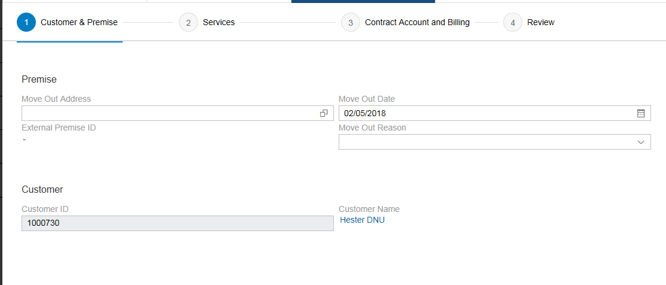
Figure 1: Guiding Procedure - Customer & Premise

Move Out Date
The ‘Move Out Date’ field is the date when the BP wants to terminate service(s) with SCE. When establishing a Move Out, this date will be defaulted to the System Date (or the current date) but can be changed to any date in the past or in the future without any restriction, subject to the following conditions:
  - There is no NMS (Network Management System) or RSS (Remote Service Switch) system limitation on volumes of Move Outs that can be processed per day nor the day of week to be completed. SCE’s normal operating days for Move Outs is week days that are not company defined holidays. We will only accept a Move Out request for a weekend day or holiday, on an exception basis, and only after we have validated we have sufficient field resources to complete the service disconnect request, in the event remote service switch does not work OR the meter is not equipped with the remote service switch. We will revisit this policy during the Process, Procedures & Policy phase of the program.
  - Move Out Date cannot be equal to or greater than a Move In Date of the same Installation. This is standard SAP validation. If the Move In Date of the existing Contract is January 3rd, then the Move Out Date can be January 2nd or prior.
  - IVR and SCE.com Move Out processing is covered in CIM-CS-13 - Manage Inbound Telephone Call – IVR and CIM-CS-10 - Manage Customer Self-Service.
  - There is no limit to the total number of Move Outs that can be processed by the NMS for Remote Service Switch. This is mentioned in Action # 343 CIM-CS-02 Number of As Of Turn-On created.
  - Based on business rules, SCE does not backdate Move Out unless it is a SCE error or the Move In BP takes responsibility with an as-of date. Backdated Move-Out date on a Contract that has been billed will not be successfully completed if the existing active contract at the premise has already been billed. Reversal of the bill is required in order for the backdated Move Out to be successfully completed in back office system (S/4HANA). To automate the bill reversal process, the System will automatically reverse the bill of the active contract via enhancement E-CIM-CS-03 - Move Out /Change/Reversal - Invoice Reversal. C4C Hybris will enable a user to complete a Move Out reversal or Move Out Date change. If needed, the front office user can also create a BPEM called ‘Move Out - Bill Reversal’ in C4C manually and it will be routed to RSO Billing to complete the request. Refer to Action # 335 Move-in Reversal by X months.
  - If there are multiple services at the Premise, the users will have the ability to enter different Move Out Dates for each individual line item, providing these dates do not conflict with the Move Out date for that individual line item.
SCE will not final bill the BP before the Move Out effective date.
The Move Out date will sync up with the actual completion date of the Move Out Service Order or Move Out Service Request completion date if the actual completion date is different than original Move Out Date. This will be done via enhancement E-DF-WM-03-Reconnection for Move-Out.

Move Out Reason can be captured by the user (optional):
  - Moving within state
  - Moving out of state
  - Vacation / Seasonal
  - Remodeling home
  - Unsafe condition / Damaged
  - Bankruptcy
  - Going out of business
  - Sold business/New owner
  - Natural Disaster
  - Credit
  - Other

- Move Out Guiding Procedure 2 - Services
In this Move Out guiding procedure (Figure 2: Guiding Procedure – Services), user will select the service(s) for the Move Out.
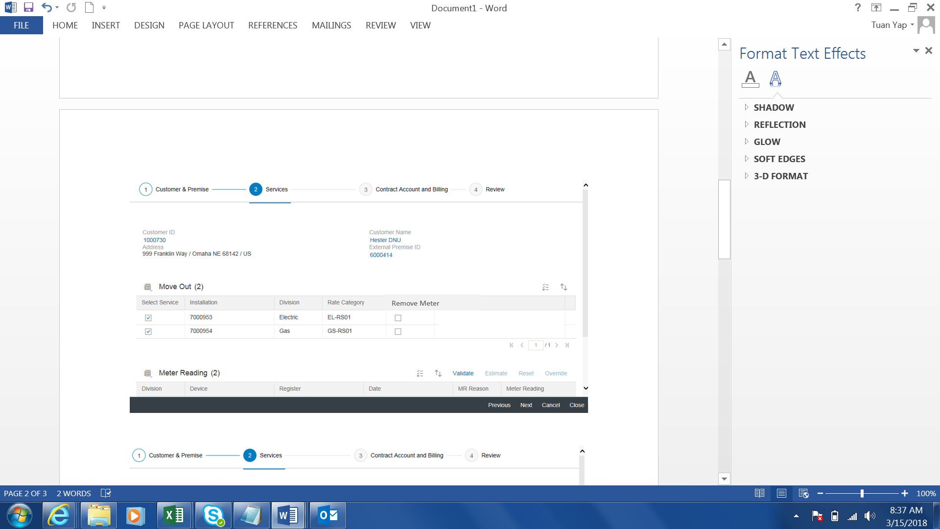
Figure 2: Guiding Procedure – Services

Move Out
The available SAP utility standard services are Electricity, Water, and Gas. Premises that offer more than one service such as Catalina area will have three line items appear on the screen for majority of the Move Out cases. All the services are automatically selected via individual checkbox. User needs to manually un-select the service(s) that the BP does not wish to terminate.
Premise with metered or unmetered residential streetlight will also have additional service line item(s) appearing on the screen. For metered streetlight, user will submit the Move Out for all services including metered streetlight and Move Out process as per normal. For Move Out involving unmetered streetlight, user will not proceed with the move out. User will create a BPEM Case category ‘Move Out - Unmetered Streetlight’ would be issued to RSO Billing to update contract term and create the Move Out when ready.
A customized check box ‘Remove Meter’ is introduced. There are some instances where BP requests to terminate service and remove meter. This is applicable when BP owns the meter or meter needs to be removed due to demolition/ natural disaster or temporary power pole. User will select Remove Meter check box in Move Out Guiding Procedure 2. Upon submitting the Move Out request, system will create a Meter Removal Service Order and sub type of Move Out. Field personnel will go to the site to remove meter and capture final meter read. Remove Meter check box and a Remove Meter Service Order creation will be done via enhancement E-CIM-CS-02 - Create Work Order during Move-In/Move-Out/Transfer.
If the BP is requesting to remove the meter but not terminating the service, user will create a Service Order via Service Order functionality in Hybris C4C and not submitting a Move Out. Refer to BPD CIM-CS-05 - Handle Request - Process Field Work Request for more information on Service Order

Create Service Order
There should be only 1 Service Order to be created by Move Out process and sent to the field at any point of time. A Service Order created by Move Out process could have multiple sub types that reflect the type of work to be carried out at the site such as remove meter, meter replacement and capture final read.
The standard SAP Create Service Order checkbox and Description field will be hidden as the user does not need to decide if a Service Order or RSS Request needs to be created.
If the premise has a RSS capable smart meter and requires de-energize, a Move Out RSS Request will be created automatically using enhancement E-CIM-CS-02 - Create Work Order during Move-In/Move-Out/Transfer, followed by sending request to RSS at the end of Move Out process. The RSS Service Request Start Date will be the Move Out Date.
If the premise has a non-smart meter which is a Register Read, a Move Out Order will be created automatically to get the final read using enhancement E-CIM-CS-02 - Create Work Order during Move-In/Move-Out/Transfer. Catalina premises use mechanical meters which require Register Read and field visit to go to the site to get the read. Appointment scheduling is not required for Move Out Meter Reading
If the premise has a smart meter that is not RSS capable or a non-smart meter (Interval Read), a Move Out Service Order is not required. A Billing Order will be created by the system in S/4HANA automatically and the meter reading will be provided by MDMS and populated in the Billing Order where the final bill will be created. Refer to BPD document UB-DM-03 - Process Meter & Device Data - Output MRO/MDMS Request for more information on MDMS.
Below is a summary of the kind of Service Order to be created for Move Out:
Scenario 1 : Premise has smart meter and is RSS capable
- If de-energized is not required, Service Order creation is not required.
- If de-energized is required, Disconnection Order will be created and a RSS request will be sent.

Scenario 2: Premise has smart meter and meter is not RSS capable:
- If de-energized is not required, Service Order creation is not required.
- If de-energized is required, create a Disconnection Order with subtype of ‘Move Out’.

Scenario 3: Premise has no smart meter
1. Customer has ESC Opt Out:
- If de-energize is not required, create a Move Out Service Order with sub type of Opt In to change out the meter. Final read will be obtained. The new meter will be set to on.
- If required to de-energize, create Disconnection Order with sub type of Opt In to change out meter. Final read will be obtained. The new meter will be set to off.

2. Current customer has no ESC Opt Out:
- If de-energize is not required, create a Move Out Service Order to get final read.
- If de-energize is required, create Disconnection Order with sub type Move Out to get final read.

Meter Reading
Previous or last meter reading will be displayed in the Meter Reading section, however these readings are for non-smart meter only. This section will be hidden. Capturing of meter reading will be done during the final bill schedule after Move Out is completed.

- Move Out Guiding Procedure – Contract Account and Payment
In this section, additional information such as Contract Account and mailing address is shown (Figure 3: Guiding Procedure – Contract Account & Billing).
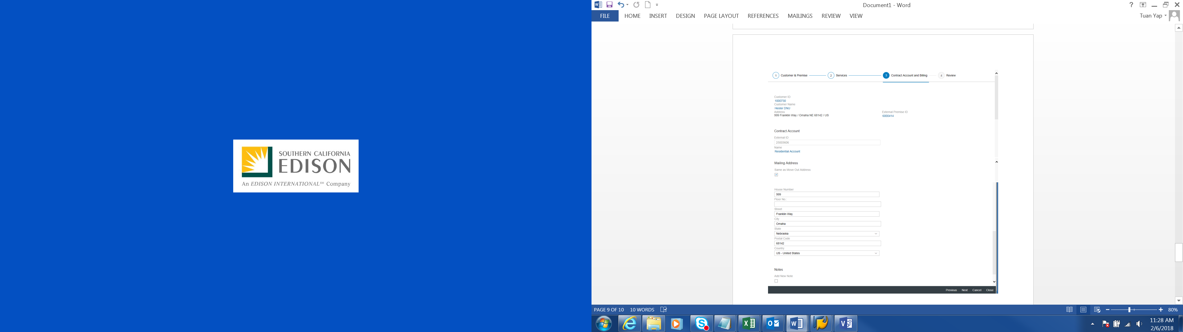
Figure 3: Guiding Procedure - Contract Account & Billing

Contract Account
The CA (Contract Account) is SAP master data object used to manage all Contracts and financial data. CA for the Contract is shown on this view. The management of the CA is detailed further in the BPD document CC-FI-01 - Business Master Data - Manage Contract Account document.

Mailing Address
The user will have the ability to update an existing mailing address or create a new mailing address. Such update will be reflected in the Business Partner master data.
Premise address will be defaulted as the Standard mailing address on the screen. If the BP does not want the premise address to be the standard mailing address, user can enter another address as standard mailing address. Refer to Decision # 39 Use service (premise) address as BP standard address.
The final bill will be sent to the mailing address currently set for the Contract Account. If the user needs to update the address for the Contract Account and if it doesn't exist for the BP, the address must be added to the BP record first. If the Contract Account has a fixed address it is an SAP best practice to update the mailing address after the Move Out is completed.

- Review
The Summary view is the final step of the guiding procedure (Figure 4: Guiding Procedure 4 – Review) where the user can recap and review the details of the elements that they have entered during the Move Out process before they proceed with the submission of the Move Out. The review of the details include:
  - The BP and Contract Account participating in the Move Out.
  - Mailing address and billing information.
  - Premise and service(s) selected for Move Out along with their respective Move Out date(s).

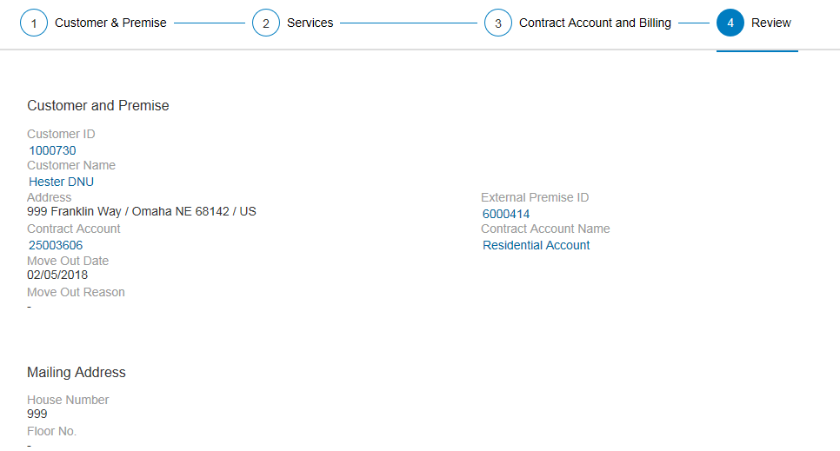
Figure 4: Guiding Procedure – Review

If mandatory data is missing during this process, the Move Out process will not be completed and the user will need to review the information and correct and / or enter the data before completing the Move Out process. Upon successful completion of the Move Out, several outputs are created in S/4HANA and they are as follows:
- Move Out Document is created,
- Contract’s Move Out Date will be updated,
- Contract will be updated directly in S/4HANA (no replication is involved)

Contract
When the Move Out has been submitted via Hybris C4C, the Contract will get updated in S/4HANA directly. Contract contains information such as the Contract Account number, Move Out Date and Installation number.
Move Out Document
Move Out document is created in S/4HANA. The Move Out document stores all data from this process including the BP and Contract data, the mailing address, bank data and consumption data. This Move Out document will also have a status field that indicates if the final meter reading has been entered, customer billed, and invoiced. The creation of the Move Out document will also trigger the creation of the Service Order for non-smart meter to complete the field activity or the RSS Request for RSS eligible smart meter for the Move Out request. The creation of Move Out Document is transparent to the user.

Security Deposit
All security deposits associated with the contract are to be released at the final billing step of the Move Out process. The Security Deposit amount will be settled during the final bill and the financial impact will be visible to the user on the Account History view, as seen in Hybris C4C. For additional details about this process and how the security deposit will be applied to the charges for the final bill, refer to the BPD document CC-FI-03 - Manage Credit - Manage Security Deposit.
As part of the Move Out process, user will ask if BP wants to receive the security deposit refund electronically or through a check (if there is still any deposit left after applied to the final bill). If customer opts for a check, user does not need to do anything. If BP opts for electronic refund using new or existing bank account, user will add the new bank account in BP master if BP gives a new bank account and then update the payment method at Contract Account.

Installation Plan
All active installment plans associated with the contract account will remain active until the Installment Plan end date. Refer to the BPD CC-FI-08 - Manage Collections (Dunning) - Manage Payment Arrangements document.

Budget Billing Plan
Any active Budget Billing Plan (BBP) associated with the Contract will be terminated by the system automatically during the final billing step of the move-out process (after Move Out is submitted). The true-up, which is the difference between the BPP and actual amount owed, is performed at final invoicing, and is detailed in the BPD UB-BI-10 - Produce Invoice - Collective and Joint Invoicing document.

Final Bill
The final bill is created via a regular batch job in S/4Hana and this is managed by the Usage & Billing team.
If a premise has multiple services and the BP is not ending all services from SCE, the remaining services that are active for the premise will still continue to get the consumption bill amount from SCE while the terminated service will get a final amount.

Owner Allocation
If an active Owner Allocation agreement exists at the location where a Move Out has been completed for the tenant, the system will automatically create a Move In for the landlord. The process is detailed in BPD CIM-CS-14 - Manage Owner Allocation document.

Program and Services
Programs & Services that are enrolled for the BP will be de-enrolled during Move Out process. Programs and Services that are stored in Installation Facts will be end-dated upon Move Out completion by system automatically if they are configured as Contract-relevant (configuration is at contract level as defined by UB). Special Programs that are stored outside of Installation Facts will not be end-dated upon Move Out completion and will need to be end dated by agent manually via the customized screen developed by Product & Program. Refer to BPD document PP-02 - Program Enrollment and Delivery, De-Enrollment & Decommission Programs.

Capturing of notes
User will capture notes during Move Out process as an Activity in Hybris C4C manually. The detail information will be documented in the Activity’s long text. The user will list the requester’s first and last name, relationship to the account holder and call back phone number or email address as the first entry in the free form notes field. This applies if it is the account holder that is calling or if an authorized caller calls on behalf of BP. A customer contact will be created automatically when the Move Out is initiated from IVR or SCE.COM. This will be handled and documented in BPD document CIM-CS-10 - Manage Customer Self-Service and CIM-CS-13 - Manage Inbound Telephone Call – IVR.

Meter Access Information
It is important to capture meter access information such as locked gate and number of dogs for every Move Out. This information will be captured outside of the Move Out process. After Move Out is submitted, user will go to Service Order view and enter the meter access information in the Service Order note(Figure 5: Service Order note) via Hybris C4C. Information captured will be shown on the Service Order note. Refer to BPD document DF-WM-02 – Handle Field Orders – Manage Field Orders for more information.
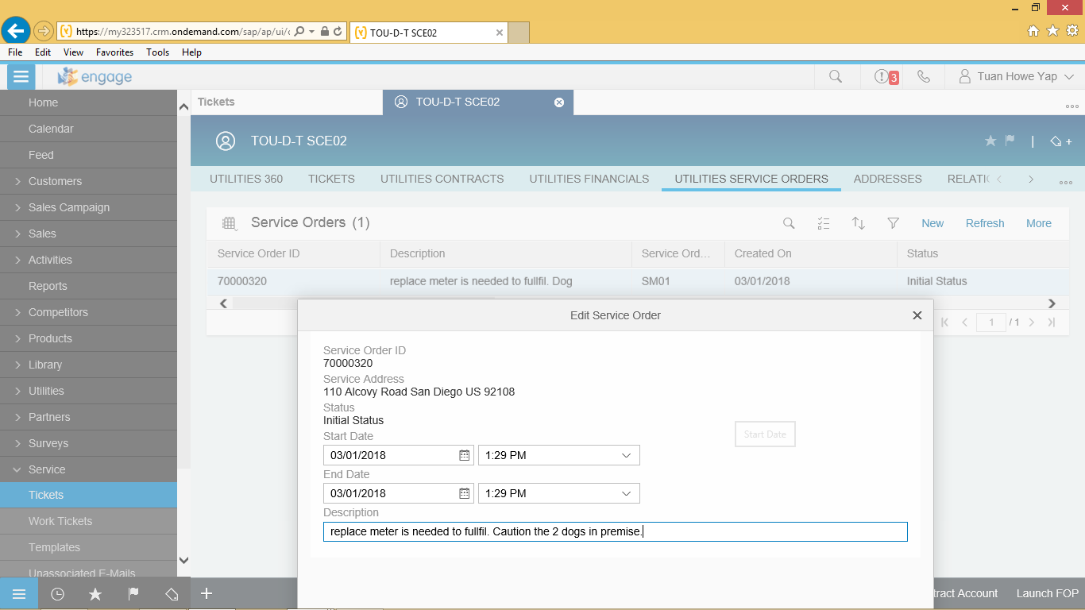
Figure 5: Service Order note

Refer Move Out to Offline Support
User may create a Ticket when the Move Outs to be executed for the BP exceeds the limit as defined by the business (e.g., 6) or call volumes are high. This is to better utilize user time in serving other BPs and allowing the Offline Support team (OLS) to handle the Move Outs. User will create a Ticket category ‘Move Out Exceeds Number of Transaction’ manually in Hybris C4C and Ticket will route to an offline support team. The offline support team will attend to the Ticket and contact the BP to carry out the Move Out.

Added Facility
If the move out premise has Added Facility, BP will usually contact CCC/ BCD Account Executive when requesting a Move Out. Added Facility identifier resides as a Division in an Installation. Added Facility can be easily seen as an additional line item along with other division such as Electric, Gas and Water in Move Out view as seen in Figure 2: Guiding Procedure – Services. User will advise the BP that it will take up to 10 business days to research the contract and identify if any termination charges apply. BP will also be advised that termination of Added Facility can occur no earlier than 30 days from the notice.
User will submit the Move Out. User will create a billing block for the contract (Figure 6: Set Billing Block) and create a BPEM case category ‘Move Out – Added Facility’ in Hybris C4C. The BPEM case will be routed to T&D to modify the agreement and reassign to BCD if needed. T&D will then assign the BPEM case to RSO Billing. RSO Billing attends the BPEM case and decide if the Added Facility can be removed from the premise by flagging and determine the termination charges. RSO Billing will remove billing block and mark Added Facility Installation as deleted in S/4HANA if applicable. The Move Out will not create a Service Order or RSS Request for the Added Facility Contract.
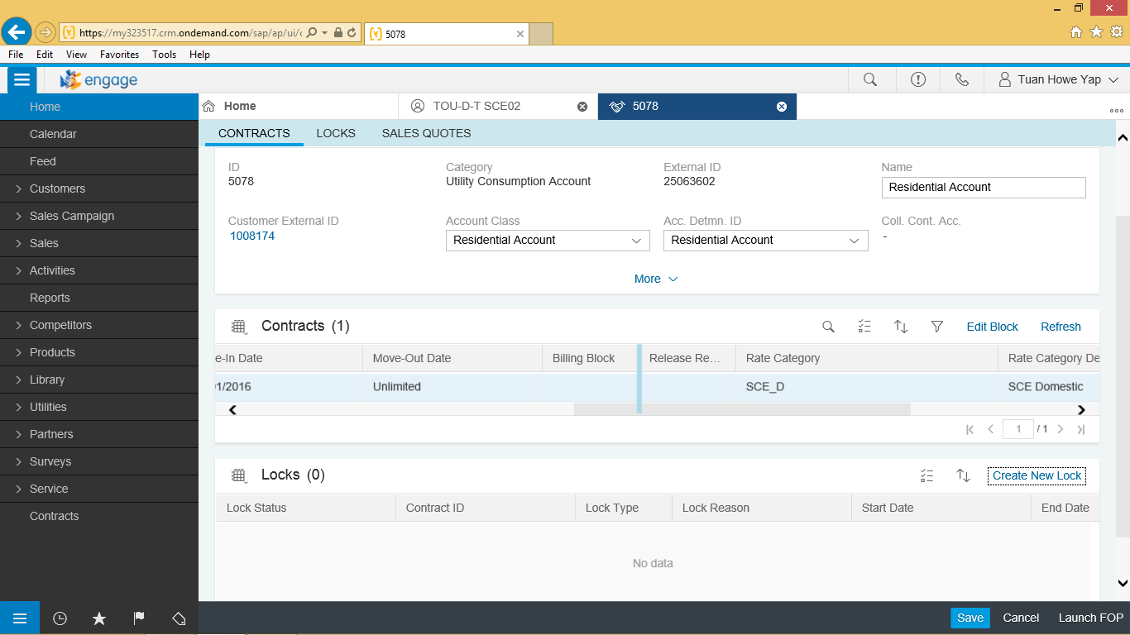
Figure 6: Set Billing Block

CCA/DA
User is able to do Move Out for CCA/DA contract, there is no restriction. CCA/DA contract will be dropped via IDEX process, refer to BPD UB-ID-02 Process EDI Contracts – Drop for more information.

Meter Replacement
If the premise has a non-smart meter, a Meter Change Out Service Order will be created automatically to change out the non-smart meter to smart meter after the Move Out effective date. SCE has 15 days to change out the meter via enhancement E-CIM-CS-02 - Create Work Order during Move-In/Move-Out/Transfer. If a new BP moves in prior to the meter being changed to a smart meter, the BP will get billed with consumption on the day BP moved in and not the date the meter is changed out. Refer to BPD document DF-WM-02 - Handle Field Orders - Manage Field Orders for more information.

Self-Certified Sensitive
Self-Certified Sensitive is identified using BPEM Case and Supply Guarantee in Installation. If Move Out is on a premise that was identified as Self-Certified Sensitive, User needs to remove the Supply Guarantee flag (Figure 7: Supply Guarantee) from Installation prior submitting the Move Out. User will also close out the Self Certified BPEM case manually. Alternatively, the BPEM case will appear in the BDEx report for RSO to close out the BPEM case when it reaches 90 days.
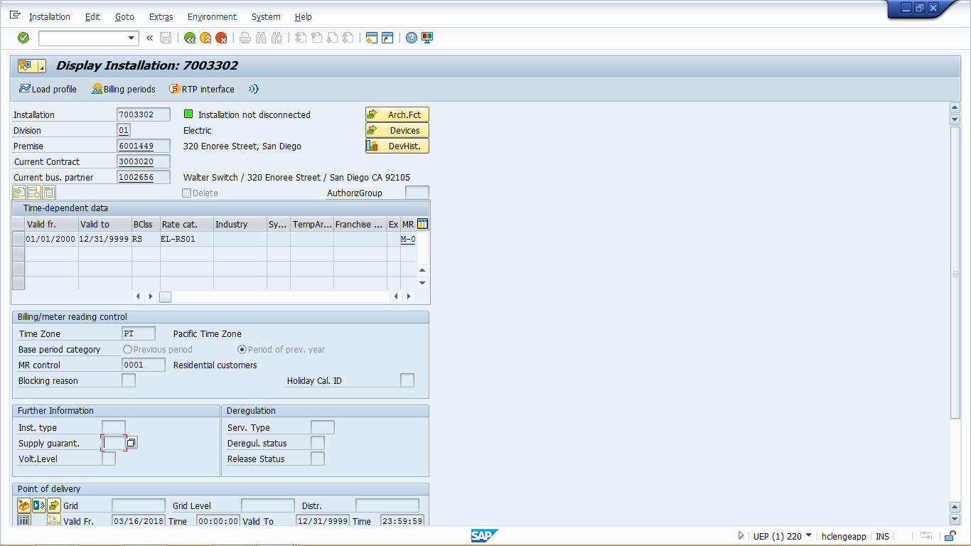
Figure 7: Supply Guarantee

Disconnection
A Disconnection Document may be created automatically after Move Out is submitted. A Disconnection Document is needed in order to disconnect the service at the premise.
Disconnection Document will be created based on the business rules below:
  - When there is no active Owner Allocation agreement found for the Installation,
  - When there is no pending Move In Contract found for the same Installation on the next calendar day. For example, if the Move Out is requested for Friday and pending Move In is requested for Monday, or after, then a Disconnection Document will be created.
Disconnection Document will not be created on the business rules below:
  - If there is an OA agreement for the premise and the Move Out is requested then the service remains on and owner will move in automatically. No Disconnection Document will be created.
  - If the power is already off due to Credit Disconnection (Dunning) then Disconnection Order is not required
For more information about Disconnection Document, refer to BPD document DF-WM-03 - Handle Remote Orders - Manage Remote Orders. The enhancement to create Disconnection Document is identified by DF-WM-03 using E-DF-WM-03 – Disconnection for Move Out.

OBF (On Bill Financing)
When a customer has an active OBF loan and move out is initiated, the customer will be billed-in-full. Please refer to BPD, CC-FI-15 Handle Account Adjustments – Manage Miscellaneous Postings.

SB 120 – Rental Property
If the premise is identified as a rental property, user needs to remove the rental property setup from BP record if required. To identify if premise is a rental property, user locates the landlord or tenant BP record in Hybris C4C (Figure 8: BP Relationship). If there is a ‘Landlord-Tenant’ relationship setup between the landlord and tenant BP, user needs to delete the BP relationship via Hybris C4C (Figure 6: BP Relationship) during or after Move Out is submitted. Refer to BPD CIM-CS-01 - Business Master Data - Manage Business Partner for steps to end date a BP Relationship.
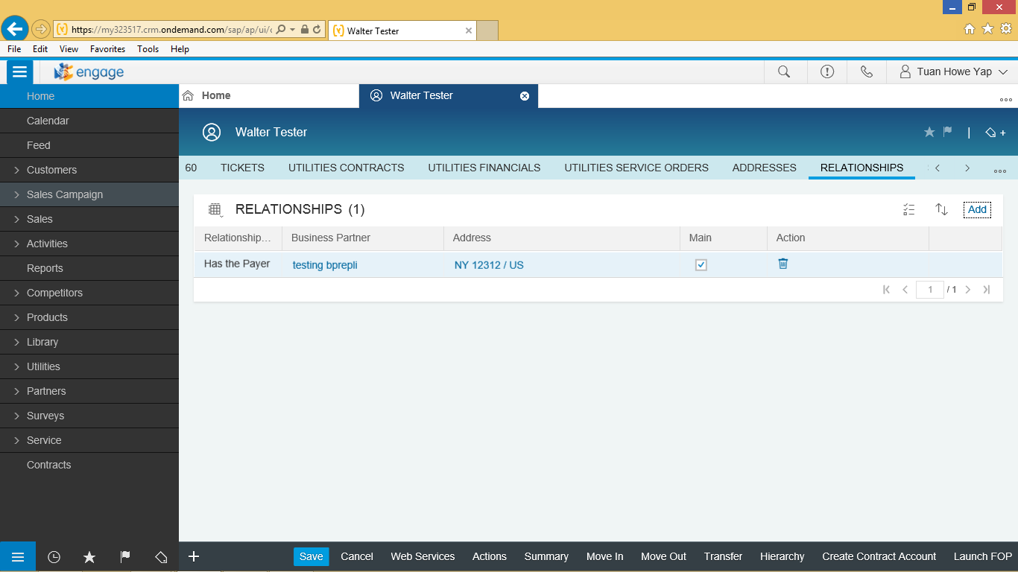
Figure 8: BP Relationship

NEM Aggregation
To identify an existing or previous customer who was enrolled in NEM, user would navigate to C4C Billing Parameter facet at Utility Rate Change option (Figure 9: Billing Parameter). Installation Facts will contain NEM item. Refer to BPD document UB-BI-12 Calculate Energy Bill - Net Metering for additional information such as automatic creation of BPEM case.
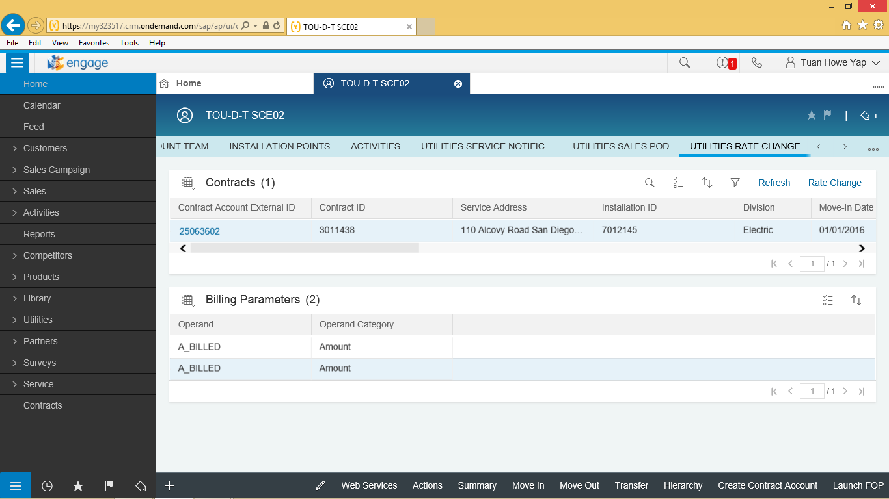
Figure 9: Billing Parameters

Water Flow Restrictor
If a BP requests a Move Out for their water service and there is a water restrictor, the user will complete the following steps:
- Issue the Move Out request
- Place a Billing block to the Contract via Hybris C4C
- Create a work order to remove the water restrictor
- Create a BPEM case ‘Flow Restrictor removal’ via Hybris C4C manually. BPEM case will be routed to RSO Billing.
RSO Billing will perform the following steps:
- Post applicable service fees on the account (e.g., water removal fee)

Catalina Field services will complete the work order to remove the water restrictor and the system shall automatically end date the installation facts for the devices and remove Billing Block from Contract in S/4HANA using E-DF-WM-02 - BRF Plus for basic service order.

Move Out Date Change Details
Whenever a BP wants to change the Move Out date of their Contract, the user will execute a Change Move Out Date process. Changing the Move Out Date of the contract is applicable to all kinds of contracts. During the Change Contract End Date process, the user is able to select a past date or a future date as the Move Out date (Figure 10: Move Out Date Change). There is no restriction as to the limit on number of days in the past or future. Whereas CCC/BCD users would encourage requestors to submit Move Out Date Changes within 30 days in the past or 1 bill period and unlimited days in the future. C4C Hybris will enable the user to submit a Move Out date change in the past or future. If needed, the user will create BPEM case ‘Move Out – Bill Reversal’ manually and it will be routed to RSO to complete the request. If there is a move out for the premise and user tries to change the Move Out Date past the new Move In Date of the new Contract, SAP will not allow user from changing the Move Out date.
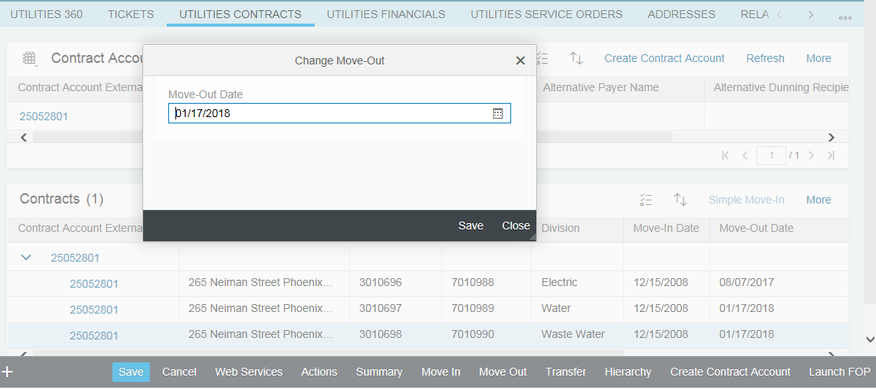
Figure 10: Move Out Date Change

The conditions below must be met for Move Out Date Change to occur are:
  - The new Move Out Date is greater than the Move In Date of the Contract. If the customer requests the move out date to be after the date of the move in.
  - The new Move Out Date should not fall in a period that has already been billed. However, an enhancement will make this Move Out Date change possible by reversing the bill(s) automatically from the new Move Out Date onwards via E-CS-CIM-03 Move Out /Change/Reversal - Invoice Reversal.
  - The new Move Out Date does not overlap with the previous contract
  - Changing of the Move Out date will not automatically adjust the Move In date of the new/ force out contract. User will need to check if there is any pending Move In and adjust the Move In date of the pending Move In accordingly. Additionally, the following conditions also apply during the Move Out Date Change process:
    - If the Move Out Service Order is in pending status, the Move Out Service Order start date will be updated. This will be done via enhancement W-CIM-CS-02 - Align New Move-In date to Service Order.
    - New Move Out date will be updated to RSS, this will be done via enhancement W-CIM-CS-02 - Align New Move-In date to Service Order.
    - Change of Move Out date is not allowed if the Move Out Service Order is in completed status and service to the premise has ended. An error message will be shown in Hybris C4C informing the Move Out Date Change is not allowed. This will be done via enhancement W-CIM-CS-02 - Align New Move-In date to Service Order.
Any associated Service Order Start Date with the end contract process will be updated automatically to reflect the change of the Contract End Date. This will be done via W-CIM-CS-02 - Align New Move-In date to Service Order.
In the case that the end date is changed or cancelled the user should be aware that the mailing address needs to be considered. Neither of these standard screens include the mailing address, therefore, the user will need to validate the customer’s mailing address manually after performing an adjustment to an existing move out.

Capturing of notes
User will capture any notes during Move Out Date Change Process as an Activity in Hybris C4C manually. The detail information will be documented in the Activity’s long text. The user will list the requester’s first and last name, relationship to the account holder and call back phone number or email address as the first entry in the free form notes field. This applies if it is the account holder that is calling or if an authorized caller calls on behalf of BP.
A BP Contact will be created automatically when the Move Out Date Change is initiated from IVR or SCE.COM. This will be handled and document in BPD document CIM-CS-10 - Manage Customer Self-Service and CIM-CS-13 - Manage Inbound Telephone Call – IVR.

Programs & Services
End date of the programs & services enrolled by BP will be adjusted automatically after Move Out Date Change is completed. Refer to BPD document PP-02 - Program Enrollment and Delivery, De-Enrollment & Decommission Programs for more information.

CCA/DA
If the Contract is CCA or DA user will not execute the Move Out Date Change. User will create a BPEM Case category ‘Move Out Adjustment - CCA/DA’ manually and BPEM case will be routed to RSO. An EDI Contract Data Update process will be executed by RSO. RSO will execute the Move Out Date Change. If there is any usage, RSO will do a bill reversal and rebill manually. In addition, RSO will send a maintenance transaction to CCA/DA informing them about the change.
Refer to BPD UB-ID-03 Process EDI Contracts – Data Changes for more information.

RSS Request & Service Order
Changing of the Move Out date will not automatically adjust the RSS Request or Service Order end date within SAP Standard. An enhancement has been identified to update RSS Request and Move Out Meter Read Order start date if Service Order status is not ‘In route’, ‘On site’, ‘Completed’. This will be done using enhancement W-CIM-CS-02 - Align New Move-In date to Service Order.
Disconnection Document date will get updated as well if applicable so that date is aligned with new Move Out date.
If system is not able to update the new Move Out date to Service Order due to status, a message will be shown in Hybris C4C that Move Out Date Change is successful but new Move Out date failed to be updated to Service Order. User will needs to create a new Reconnect Order with today’s date followed by a new Disconnect Order with actual Move Out date.

Appointment Scheduling
There is no appointment scheduling required with CLICK for Move Out Date Change.

Move Out Reversal Details
Should the BP desire to cancel the Move Out request, the user will execute the Move Out Reversal process (Figure 11: Move Out Reversal) to reinstate the Contract and choose a cancel reason, presuming the following conditions exist:
- The utility Contract has yet to receive a final bill.
- No subsequent utility Contract exists at that location for the same Installation.

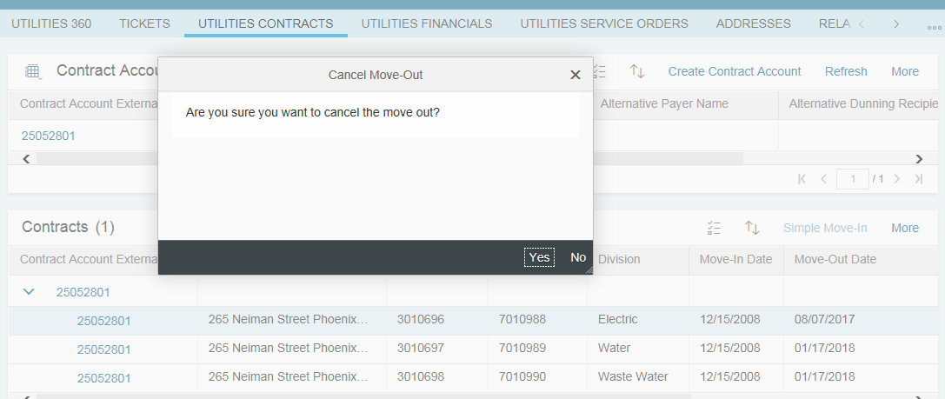
Figure 11: Move Out Reversal

If the contract has been final billed, the final bill and billing documents must be reversed before the contract end date can be changed. System will reverse the final bill and billing documents automatically from the new Contract End Date onwards via E-CS-CIM-03 Move Out /Change/Reversal - Invoice Reversal. Installation Facts operand that has been end dated by Move Out process automatically will be re-activated by Move Out process. When applicable, the user will need to manually reinstate the following that may be deactivated during final bill or Contract End process. Design is pending completion of input from other BPDs:

- Installment Plan
- Installation Facts operand that has been end dated
- On Bill Financing
- Contract level preferences

Additionally, the following conditions also apply during the Move Out Reversal process:
- A user will be allowed to Cancel Contracts for a BP who is enrolled with a CCA/DA
- If a future dated Move In exists for the premise, the Move In will need to be canceled first before the Move Out reversal can be executed.

RSS Request & Service Order
By reversing the Move Out request, the system will cancel the Move-Out RSS Request and Move Out Service Order for the premise automatically if the Service Order status is not ‘In route’, ‘On site’ or ‘Completed’ using W-CIM-CS-02 - Align New Move-In date to Service Order. If the Service Order status is ‘In route’, ‘On site’ or ‘Completed’, system will show message about Move Out Reversal is successful but Service Order not able to be canceled and user will create a new Service Order manually to connect the service to the premise.
The Disconnection Document needs to be canceled. If the Disconnection Order in the Disconnection Document is already completed, system will create a Reconnection Order for the Disconnection Document to reconnect the service at the premise. This enhancement will be done using E-DF-WM-03 – Disconnection for Move-Out.

Capturing of notes
User will capture any notes during Move Out Reversal Process as an Activity in Hybris C4C manually. The detail information will be documented in the Activity’s long text. The user will list the requester’s first and last name, relationship to the account holder and call back phone number or email address as the first entry in the free form notes field. This applies if it is the account holder that is calling or if an authorized caller calls on behalf of BP.
A Customer Contact will be created automatically when the Move Out Reversal is initiated from IVR or SCE.COM. This will be handled and document in BPD document CIM-CS-10 - Manage Customer Self-Service and CIM-CS-13 - Manage Inbound Telephone Call – IVR.

Programs & Services
User needs to manually re-enroll the Programs & Services that BP previously enrolled with before the Move Out. Refer to BPD document PP-02 - Program Enrollment and Delivery, De-Enrollment & Decommission Programs for more information.

CCA/DA
If the Contract is CCA or DA, user will not create the Move Out Reversal. User will create BPEM Case Category ‘Move Out Reversal – CCA/DA’ and BPEM case will be routed to RSO. RSO will send a maintenance transaction to CCA/DA informing them about the reversal.
Refer to BPD UB-ID-03 - Process EDI Contract Data Changes for more information.

Security Deposit
A Security Deposit that has been canceled or refunded to the BP after Move Out process will need to manually be reinstated. Move Out Reversal functionality does not reinstate the deposit automatically. User will reinstate the deposit using Hybris C4C FOP functionality where S/4HANA Deposit creation screen (Tcode FPSEC1) will be shown. This will be done using enhancement E-CIM-CS-02 Transaction Launcher.

Appointment Scheduling
There is no appointment scheduling required with CLICK for Move Out Reversal.

NEM
If the Contract is NEM, Move Out reversal will reverse the Move out and BP will return to the NEM month where BP was last billed before Move Out occurred. The detail information of reinstatement of the NEM Contract to the last bill in the event of Move Out reversal is documented in BPD UB-BI-12 - Calculate Energy Bill - Net Metering.

Transfer Details
The Transfer process is managed as part of the guided procedure within Hybris C4C. This will lead to termination of Contract in a premise and starting of a new Contract in a different premise. Transfer process consists of six guiding procedures that help users navigate through each step of this process. The guiding procedures are actually made up of Guiding Procedures of Move Out process and Move In process. The six guiding procedures of Transfer process are:
- Move Out Premise
- Move Out Services
- Move In Premise
- Move In Services
- Contract Account and Billing
- Review
Validation and logic mentioned in Move Out process are applicable to Transfer Guiding Procedure 1 - Move Out Premise and Guiding Procedure 2 - Move Out Services, unless it is specifically mentioned otherwise in this document.
Validation and logic mentioned in Move In process are applicable to Transfer Guiding Procedure 3 – Move In Premise, Guiding Procedure 4 – Move In Services and Guiding Procedure 5 – Contract Account and Billing, unless it is specifically mentioned otherwise in this document.
Transfer Guiding Procedure captures Move Out information followed by Move In information. The details of each Guiding Procedures are documented below.
- Transfer Guiding Procedure 1 – Move Out Premise
In this Guiding Procedure, Move Out information is captured first. User needs to locate the Contract before initiating the Transfer Process. When the Transfer is initiated, Guiding Procedure – Move Out Premise view will be shown (Figure 12: Guiding Procedure – Move Out Premise). If the premise is not already identified before initiating the Transfer, user is able to select the Move Out Address from the Move Out Address drop down selection field. User will ask the BP for the Move Out Date and enter the date into Move Out Date field.

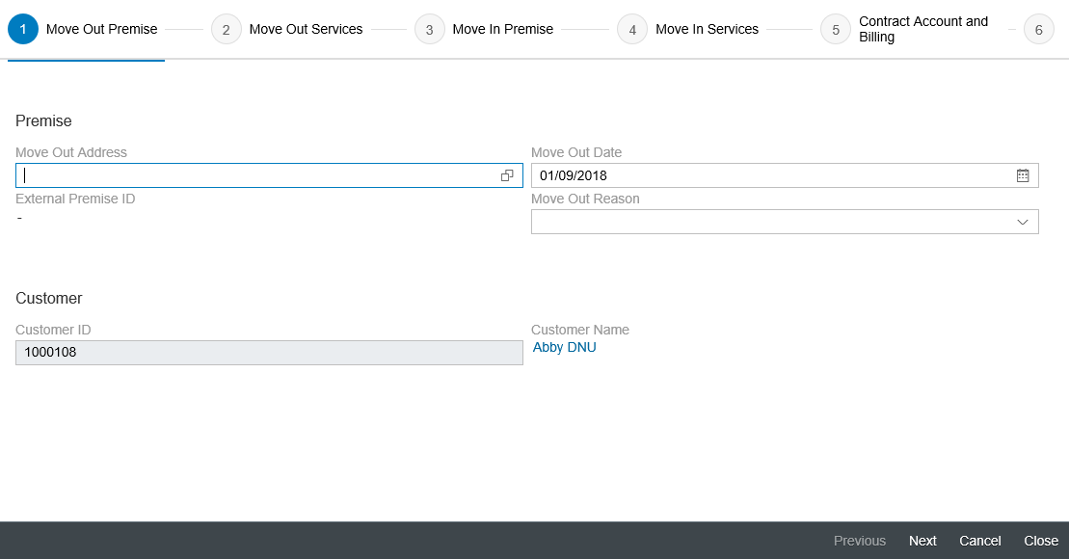
Figure 12: Guiding Procedure – Move Out Premise

- Transfer Guiding Procedure 2 – Move Out Services
In this Move Out guiding procedure (Figure 13: Guiding Move Out Services), user will select the service(s) for the Move Out.

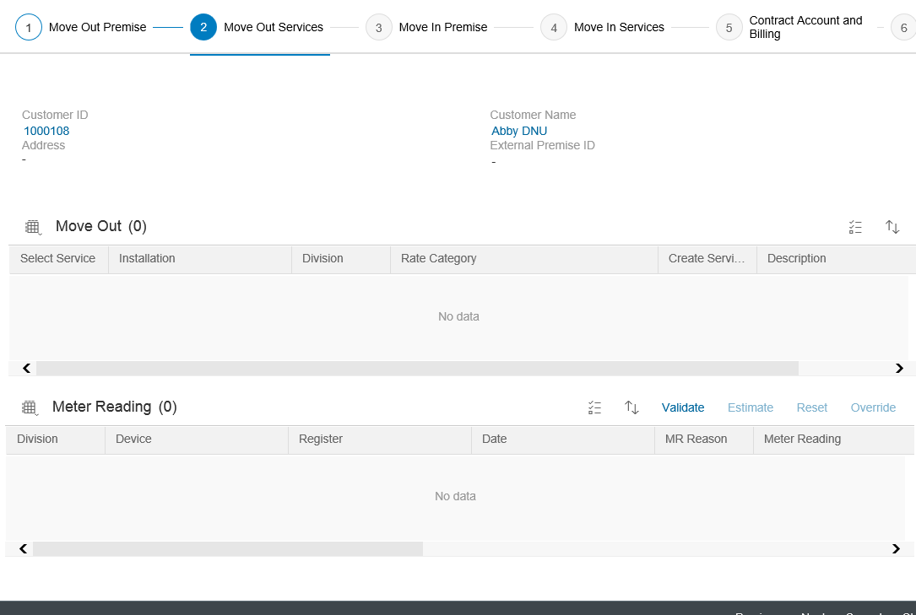
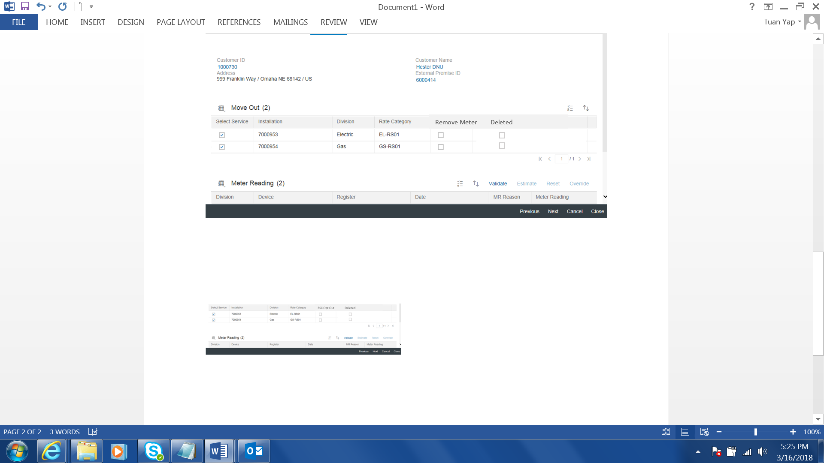
Figure 13: Guiding Procedure - Move Out Services

Move Out
List of Services that customer signed up for will be available and shown in the Move Out section. Functionality is the same as the Move Out Process.

Create Service Order
Create Service Order functionality is the same as the Create Service Order functionality in Move Out Process. The Create Service Order checkbox and Description field will be made hidden as the user does not need to decide if a Service Order or RSS Request needs to be created.

Meter Reading
Meter Reading section will be made hidden as capturing of customer read is not applicable to SCE and meter reading will be done during the final bill schedule after Move Out is completed.

- Transfer Guiding Procedure 3 – Move In Premise
Move In information is being captured in the next couple of Guiding Procedures. In this Guiding Procedure, the user will select the Move In address and the Move In date (Figure 14: Guiding Procedure 4 – Move In Premise). Validation and functionality is the same as the Move In Process. Move In Date selected does not have any dependency with the Move Out Date selected in Transfer Guiding Procedure 1 – Move Out Premise. Both dates can overlap as both dates are not referring to the same Contract.

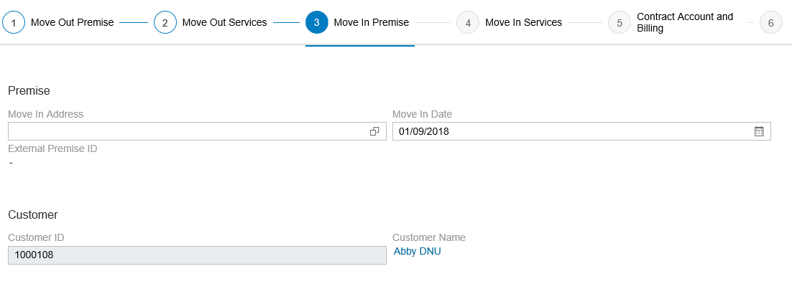
Figure 14: Guiding Procedure 4 - Move In Premise

- Transfer Guiding Procedure 4 – Move In Service
In this Guiding Procedure (Figure 11: Guiding Procedure 5 – Contract Account and Billing), user will identify the service(s) the BP would want to enroll in. List of the applicable Rate Category’s will be available for user to select. User will be able to select ESC Opt Out if required. The deleted check box is always in display mode. If Installation is marked deleted, the Deleted checkbox will be checked and the Select Service checkbox will be set to disabled. User will not able to select the line item where Deleted checkbox is checked. This will be done using enhancement E-CIM-CS-02 - Capture Opt Out, Inspection Required and service fees.
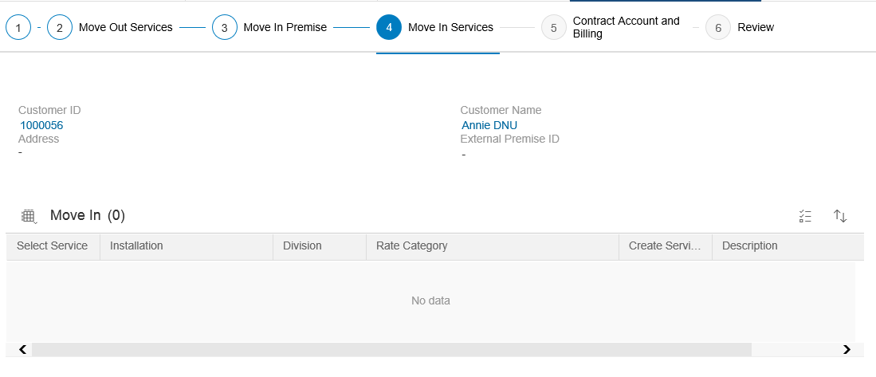
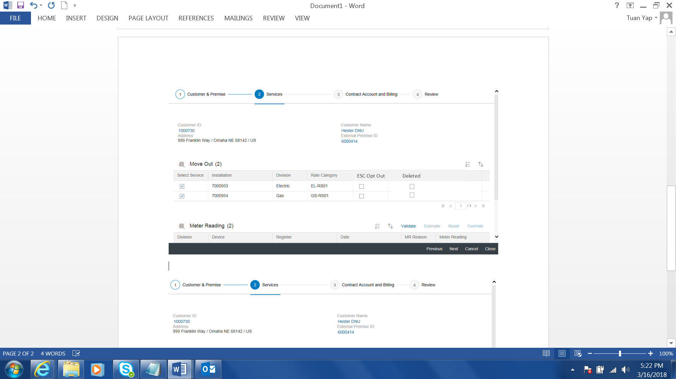
Figure 15: Guiding Procedure - Move In Service

- Transfer Guiding Procedure 5 – Contract Account and Billing
In this Guiding Procedure (Figure 16: Guiding Procedure - Contract Account and Billing), additional information such as Contract Account, mailing address and Security Deposit will be captured.
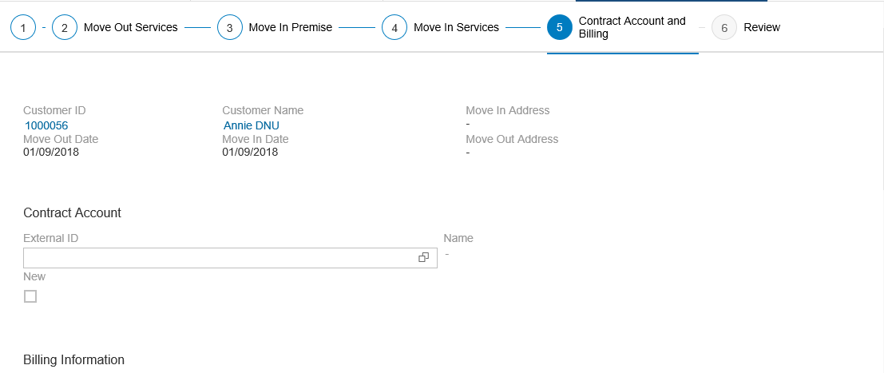
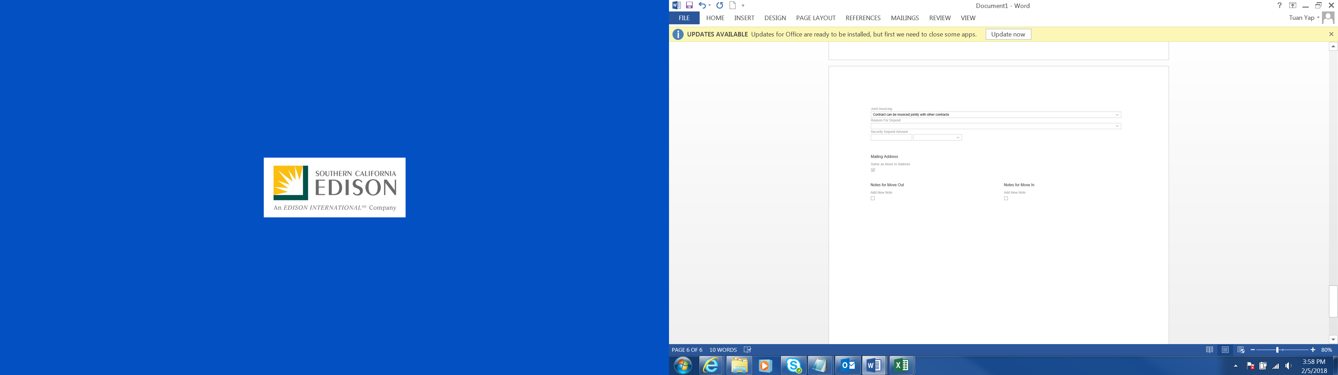
Figure 16: Guiding Procedure - Contract Account and Billing

Security Deposit
Refer to CIM-CS-02 Handle Customer Move-In/Out – Contract New.

- Transfer Guiding Procedure 6 – Review
In this Guiding Procedure (Figure 17: Guiding Procedure – Review), information captured throughout the Transfer process is shown in this view for user to verify the information with the BP before submitting the Transfer Request.

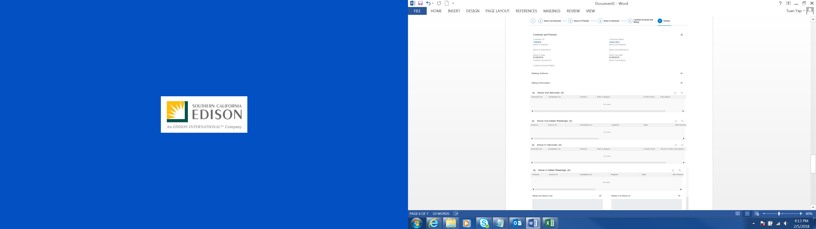
Figure 17: Guiding Procedure - Review

Paperless Billing (e-Bill)
If the BP has signed up for e-Bill at the old premise, BP will continue to receive e-Bill at the new premise. The e-Bill indicator is stored in the Contract Account and the Contract Account will be reused during Transfer process, hence the continuance of BP receiving e-Bill at the new contract.
If the BP did not sign up for e-Bill at the old premise, user will need to enable e-Bill in Hybris C4C via FOP. This will be done via E-CIM-CS-02 Transaction Launcher.

Programs & Services
Depending program eligibility, Programs and Services that BP has signed up for in the old premise will be transferred automatically to the new premise after Transfer is completed. Refer to BPD document PP-02 - Program Enrollment and Delivery, De-Enrollment & Decommission Programs for more information.

CCA
When BP has opted out of CCA from the moving out premise and transferring within the same CCA territory, customer does not need to opt out CCA again.
When BP has opted out of CCA from the moving out premise and transferring to a different CCA territory, customer does need to opt out CCA if desired.
When BP has opted out of CCA from the moving out premise and transferring to a Non-CCA territory, no CCA opt in or opt out required.

Process / Performance Improvement
- Ability to navigate away from Move Out or Transfer View view without cancelling the transaction
- Increase visibility and improve overall process efficiency by reducing hands off by allowing BCD to execute Contract End functionality

Prerequisites and Inputs
A request to create or change Move Out and Transfer may originate via the following channels or systems:
  - SAP systems & SCE.COM need to be available for Web Self Service
  - IVR system needs to be available for IVR
  - Contract must exists in S/4HANA
  - Move-Out date is determined
  - Contract is active and moved out is not carried out to the Contract
  - BP, Contract Account, old and new premise must exist before Transfer process is initiated

General Assumptions
- CCC, BCD, RSO CBO, RSO CAPS, and other front office users will be executing Move Out, Move Out adjustment and Move Out reversal.
- Some Programs & Services will be stored in SAP as a Rate Category or Installation Facts.
- In the event of Move In Date Change and Reversal, the Program & Service will be updated by Program and Product’s program automatically. This is with the assumption that PP RICEFW items associated with these functionalities are approved in their BPD
- All users are advised to issue a move-out (e.g. bankruptcy situations) via Hybris C4C.
- T&D will accept BPEM
- If there is a Smart Meter, there is no need to create a RSS Service Order to obtain a final read as the interval data will be used. The Final bill will use the meter reading from the last Interval read of the day of move out.

Business Process Hierarchy
This Business Process Hierarchy provides a listing of all scenarios/business processes, sub-processes, and SAP Transaction codes identified to support this process.
Level 1 | Level 2 | Level 3 | Level 4
FO | Handle Customer Move-In/Out | Contract End | Create Move Out
FO | Handle Customer Move-In/Out | Contract End | Change Move Out Date
FO | Handle Customer Move-In/Out | Contract End | Move Out Reversal
FO | Handle Customer Move-In/Out | Contract End | Transfer

Process Flows
This BPD will cover four processes, including Create Move Out, Move Out Date Change, Move Out Reversal and Transfer processes. Each subsection where the process is detailed will have a process flow diagram for that process and a table detailing the steps that are taken within that process including processes handled outside of SAP.

Create Move Out
This process flow describes the process of create Move Out.

Process Flow Diagram

Process Flow Steps

Step | Description of Step | C4C / T-Code | Role(s) | If step is relevant for a Control, add Requirement  ID
10 | Customer contacts SCE via phone  BP calls CCC or BCD to request for Move Out. | N/A | N/A
20 | Authenticate BP  Validate Requestor is authorized to request Move out Date Change | Hybris C4C | Create Move Out | Control identified
30 | Exceeds number of transaction?  If number of Move Out to be executed exceeds the number defined by SCE, go to step 40. Otherwise, go to step 50. | N/A | Create Move Out
40 | Create Ticket  Ticket is created and routed to the respective group to work on. Proceed to step 370. | Hybris C4C | Create Move Out
50 | Added Facility/Water Restrictor?  If the move out is for Added Facility or Water Flow Restrictor, go to step 60. Otherwise, go to step 70. | Hybris C4C | Create Move Out
60 | NEM Aggregation?  If Contract is NEM Aggregation, go to step 70. Otherwise, go to step 90. | Hybris C4C | Create Move Out Processing
70 | Handle NEM Move Out  UB-BI-12 process handles NEM Move Out which includes creation of BPEM case. | Hybris C4C | Create Move Out
90 | Self-Certified Sensitive?  If Installation is tagged as Self-Certified Sensitive, go to step 100. Otherwise, go to step 110. | Hybris C4C | Create Move Out
100 | Remove Supply Guarantee flag  Remove the Self-Certified flag from Supply Guarantee field in Installation. | Hybris C4C | Create Move Out
110 | Execute Move Out  Execute Move Out process in system. | Hybris C4C | Create Move Out
120 | Select Move Out Date  Choose a Move Out date. | Hybris C4C | Create Move Out
130 | Determine Mailing address  Option to capture forwarding address or use existing mailing address as forwarding address. | Hybris C4C | Create Move Out
140 | Review Move Out  Review the information captured during Move Out process before submitting the request. | Hybris C4C | Create Move Out
150 | Submit Move Out  Click Submit button to submit Move Out | Hybris C4C | Create Move Out
160 | Auto Programs & Services decommission  Programs & Services are decommissioned automatically | Hybris C4C | Create Move Out Processing
170 | De-activate Critical Care identifier  Critical Care identifier will be de-activated by system automatically if applicable | Hybris C4C | Create Move Out Processing
180 | Capture meter access information  Capture meter access information in Service Order note | Hybris C4C | Create Move Out
190 | Create Activity  Create an Activity Record and document the information in the long text. Proceed to step 370. | Hybris C4C | Create Move Out
200 | Contract End Date is updated  Contract End Date is updated with Move Out Date | S/4HANA | Create Move Out Processing
210 | Move Out Document is created  Move Out Document is created | S/4HANA | Create Move Out Processing
220 | Disconnection required?  If Disconnection Document is required to be created, go to step 230. Otherwise, go to step 240. | S/4HANA | Create Move Out Processing
230 | Create Disconnection Document  Disconnection Document and Disconnection Order (for the Disconnection Document) is created. | S/4HANA | Create Move Out Processing
240 | RSS Request required?  If RSS Request is required, go to step 250. Otherwise go to step 260. | S/4HANA | Create Move Out Processing | Control Identified
250 | Handle Remote Order  RSS Request is created. | S/4HANA | Create Move Out Processing
260 | Meter change needed?  If meter needs to be changed to smart meter or legacy meter, go to step 270. Otherwise, go to step 280. | S/4HANA | Create Move Out Processing
270 | Create Service Order  Meter Change Out Service Order to change out to smart meter/legacy is created. | S/4HANA | Create Move Out Processing
280 | Budget Billing Plan found?  If Budget Billing Plan is active for the Contract, go to step 290. Otherwise, go to step 300. | S/4HANA | Create Move Out Processing
290 | Budget Billing Plan is deactivated  Budget Billing Plan is deactivated. | S/4HANA | Create Move Out Processing
300 | Installation Facts Operands are end dated  Installation Facts Operands end date is updated with Move Out date. | S/4HANA | Create Move Out Processing
310 | CCA/DA?  If Contract is CCA or DA, go to step 320. Otherwise, go to step 330. | S/4HANA | Create Move Out Processing
320 | Process EDI Contract Drop  The process of EDI Contract Drop. | S/4HANA | Create Move Out Processing
330 | Bill Reversal required?  If bill reversal is required (applicable for backdated Move Out), go to step 340. Otherwise, go to step 350. | S/4HANA | Create Move Out Processing
340 | Automatic Bill Reversal  Bill(s) are automatically reversed. | S/4HANA | Create Move Out Processing
350 | Final Bill creation  Final bill is created. | S/4HANA | Create Move Out Processing
360 | Interface to RSS  RSS Request is routed to RSS. | S/4HANA | Create Move Out Processing
370 | End

Change Move Out Date
This process flow describes the process of Move Out Date Change.

Process Flow Diagram

Process Flow Steps

Step | Description of Step | C4C / T-Code | Role(s) | If step is relevant for a Control, add Requirement  ID
10 | BP contacts SCE via phone  BP calls CCC or BCD to request for Move Out Date change. | N/A | N/A
20 | Authenticate BP  Validate Requestor is authorized to request Move out Date Change | Hybris C4C | Move Out Date Change | Control identified
30 | CCA/DA?  If Contract is CCA or DA, go to step 40. Otherwise, go to step 50. | Hybris C4C | Move Out Date Change
40 | Create BPEM case  Create BPEM case manually. | Hybris C4C | Move Out Date Change
50 | Execute Move Out Date Change  User execute Move Out Date Change functionality | Hybris C4C | Move Out Date Change
60 | Is bill created?  If bill is created for the contract, go to step 40. Otherwise, go to step 50. | N/A | N/A
70 | Bill reversal required & > than x bill cycle?  If bill reversal is required and more than x billing cycle, go to step 90 to create BPEM. Otherwise go to step 80. | Hybris C4C | Move Out Date Change
90 | Create BPEM  Create Move Out Bill Reversal BPEM case. | Hybris C4C | Move Out Date Change
80 | Automatic bill reversal  Bills are automatically reversed via enhancement. | EA20 | Process Move Out Date Change
100 | Is Move Out Service Request / Service Order found?  If Move Out Service Request / Service Order found, go to step 110. Otherwise, go to step 170. | N/A | N/A
110 | Align Move Out Date to Service Request / Service Order  Enhancement to update new Move Out Date to Service request / Service Order. | S/4HANA | Process Move Out Date Change
120 | Meter is smart meter?  If meter is a smart meter, go to step 140. Otherwise go to step 130. | N/A | N/A
130 | Manage Field Orders  DF-WM-02 process handles process after Service Order start date is updated. | S/4HANA | N/A
140 | Manage Remote Orders  DF-WM-03 process updates Service Request to RSS. | S/4HANA | N/A
150 | Contract is updated  New Move Out Date is updated to Contract. | S/4HANA | Process Move Out Date Change
160 | Move Out Document is updated  New Move Out Date is updated to Move Out Document | S/4HANA | Process Move Out Date Change
170 | Update Programs & Services  Programs & Services are updated automatically by system | Hybris C4C | Process Move Out Date Change
180 | Create Activity  User creates an Activity documenting the information in the long text | Hybris C4C | Move Out Date Change
190 | End | N/A | N/A

Move Out Reversal
This process flow describes the process of Move Out Reversal

Process Flow Diagram

Process Flow Steps

Step | Description of Step | C4C / T-Code | Role(s) | If step is relevant for a Control, add Requirement  ID
10 | BP contacts SCE via phone.  BP calls SCE to request to Move Out Reversal | N/A | N/A
20 | Authenticate BP  Verify requestor is authorized to change the Move out Date | Hybris C4C | Move Out Reversal | Control identified
22 | CCA/DA?  If Contract is CCA or DA, go to step 28. Otherwise, go to step 30. | Hybris C4C | Move Out Reversal
28 | Create BPEM case  Create BPEM case manually. | Hybris C4C | Move Out Reversal
30 | Execute Move Out Reversal  User executes Move Out Reversal functionality | Hybris C4C | Move Out Reversal
40 | Validate mailing address  Validate mailing address in case it was changed during Move Out process | Hybris C4C | Move Out Reversal
50 | Submit Move Out Reversal  User submits Move Out Reversal. | Hybris C4C | Move Out Reversal
60 | Manual Services & Programs enrollment  Services & Programs need to be manually enrolled by user | Hybris C4C | Move Out Reversal
70 | Create Activity  An Activity Record is created and information is documented in the long text. | Hybris C4C | Move Out Reversal
80 | Has final bill been created?  If bill is created for the Contract, go to step 90. Otherwise go to step 100. | S/4HANA | Process Move Out Reverse
90 | Automatic bill reversal  Enhancement to have bill(s) for the contract automatically reverse. | EA20 | Process Move Out Reverse
100 | Move Out related Service Request/ Order found?  If Service Request or Service Order created by Move Out process, go to step 110. Otherwise go to step 120. | S/4HANA | Process Move Out Reverse
110 | Cancel Move Out related Service Request/Order.  Service Request and Service Order status is canceled. | S/4HANA | Process Move Out Reverse
120 | Smart meter?  If meter is a smart connect meter, go to step 150. Otherwise, go to step 130. | S/4HANA | Process Move Out Reverse
130 | Contract is updated  Move Out date is removed from Contract End date | ES21 | Process Move Out Reverse
140 | Move Out Document is marked deleted  Move Out Document is updated | EC56E | Process Move Out Reverse
150 | Cancel RSS Service Request  A cancel Service Request is sent to RSS. | S/4HANA | Process Move Out Reverse
160 | End

Transfer
This process flow describes the Transfer process.

Process Flow Diagram

Process Flow Steps

Step | Description of Step | C4C / T-Code | Role(s) | If step is relevant for a Control, add Requirement  ID
10 | BP contacts SCE via phone  BP calls CCC/BCD via phone call. | N/A | N/A
20 | Authenticate BP  Verify the requestor is authorized to Transfer service | Hybris C4C | Transfer | Control identified
30 | Exceeds number of transaction?  If number of Move Out to be executed exceeds the number defined by SCE, go to step 40. Otherwise, go to step 50. | N/A | Transfer
40 | Create Ticket  BPEM case is created and routed to the respective group to work on. Proceed to step 370. | Hybris C4C | Transfer
50 | Added Facility/Water Restrictor?  If the move out is for Added Facility or Water Flow Restrictor, go to step 60. Otherwise, go to step 70. | Hybris C4C | Transfer
60 | NEM Aggregation?  If Contract is NEM Aggregation, go to step 80. Otherwise, go to step 70. | Hybris C4C | Transfer Processing
70 | Set Billing Block  Update Contract with Billing Block. | Hybris C4C | Transfer
80 | Create BPEM case  User creates a BPEM case manually. | Hybris C4C | Transfer
90 | Self-Certified Sensitive?  If Installation is tagged as Self-Certified Sensitive, go to step 100. Otherwise, go to step 110. | Hybris C4C | Transfer
100 | Remove Supply Guarantee flag  Remove the Self-Certified flag from Supply Guarantee field in Installation. | Hybris C4C | Transfer
110 | Execute Transfer  Execute Transfer functionality. | Hybris C4C | Transfer
120 | Select Move Out Date  Choose a Move Out date. | Hybris C4C | Transfer
130 | Select Services to move out  Select the services (electricity, gas, water etc.) to terminate service. | Hybris C4C | Transfer
140 | Starting Move In Guiding Procedures  Guiding Procedures for Move In is shown. | Hybris C4C | Transfer
150 | Smart Meter Opt In/ Opt Out  Capture the Opt In/ Opt Out for Smart Meter | Hybris C4C | Transfer
160 | Meter change needed?  If meter required to be changed, go to step 100. Otherwise, go to step 110. | Hybris C4C | Transfer Processing
170 | Service Order issued to change meter  Service Order will be created to change out the meter to smart meter | Hybris C4C | Transfer Processing
180 | Select Move In Date  Choose a Move In date. | Hybris C4C | Transfer
190 | Select Service(s)  Select the services (electricity, gas, water, added facility) for Move In. | Hybris C4C | Transfer | Control identified
200 | Select Rate Category  Select a Rate Category. | Hybris C4C | Transfer
210 | Determine previous contract consumption  Check the kw of the previous contract | Hybris C4C | Transfer
220 | Is NEM & below/above 30 kw?  If Move In is NEM and previous contract kw is below or above 30kW, go to step 230. Otherwise, go to 250. | Hybris C4C | Transfer
230 | Create BPEM Case below or above 30kw  Create BPEM case for T&D Interconnection Agreement assessment for below or above 30kW. | Hybris C4C | Transfer
250 | Determine mailing address  Option to capture new mailing address or use premise address as mailing address. | Hybris C4C | Transfer
260 | Credit Check required?  If BP requires credit check, go to step 270. Otherwise, go to step 300. | Hybris C4C | Transfer Processing
270 | Interface with Experian.  Interface with Experian to get the credit score of BP. | Experian | Transfer Processing
280 | Customer Verification failed?  If BP failed customer verification go to step 290. Otherwise, go to step 300. | Hybris C4C | Transfer
290 | Create BPEM  BPEM case is created and routed to the respective group to work on. | Hybris C4C | Transfer
300 | Security Deposit calculation  Security Deposit amount is derived based on business rule. | Hybris C4C | Transfer Processing
310 | Waive Deposit?  If Security Deposit is to be waived, go to step 320. Otherwise, go to step 330. | Hybris C4C | Transfer
320 | Remove Deposit amount  Delete Security Deposit amount on the screen. | Hybris C4C | Transfer
330 | Owner Allocation?  If Move In is Not Owner Allocation, go to step 330. Otherwise, go to step 360. | Hybris C4C | Transfer Processing
340 | Determine & input Service fees  Determine the fees required for the Move In. | Hybris C4C | Transfer
350 | Service Establishment fees  Service Establishment fees is required and defaulted on the screen. | Hybris C4C | Transfer Processing
360 | Gas & outside of business hour  If Service type is Gas and Move In request is outside of business hour, go to step 370. Otherwise, go to step 380. | Hybris C4C | Transfer
370 | Select outside business hour fees  System defaults fees for outside business hour. | Hybris C4C | Transfer
380 | Review Move In  Review the information captured during Move In process before submitting the request. | Hybris C4C | Transfer
390 | Safety message  Go through safety message with BP. | Hybris C4C | Transfer
400 | Submit Transfer  Click Submit button to submit Move In. | Hybris C4C | Transfer
410 | Fuse-up inspection required?  If Fuse-up inspection is required, go to step 420. Otherwise, go to step 440. | Hybris C4C | Transfer
420 | Set Billing Block  Update Contract with Billing Block. | Hybris C4C | Transfer
430 | Cancel Service Order  Cancel the Service Order. | Hybris C4C – FOP | Transfer
440 | Capture meter access information  Meter access information such as lock gate, bad dog is captured. | Hybris C4C – FOP | Transfer
450 | Capture Self-Certify  Update Installation with Self-Certify. | Hybris C4C – FOP | Transfer
460 | Auto transfer of Programs & Services  Programs & Services that BP enrolled with are transferred to the new premise. | Hybris C4C | Transfer
470 | Create Budget Billing Plan  Budget Billing Plan is created. | Hybris C4C | Transfer
480 | Create Activity Record  Create an Activity Record and document information in the long text. | Hybris C4C | Transfer
490 | Move Out Contract is end dated  Move Out Contract end date is updated. | ES21 | Transfer Processing
500 | Move Out Document is end dated  Move Out Document end date is updated. | EC50E | Transfer Processing
510 | Contract is created  Contract for Move In is created. | ES21 | Transfer Processing
520 | Move In Document is created  Move In Document is created | EC50E | Transfer Processing
530 | Disconnection is required?  If Disconnection is required, go to step 540. Otherwise, go to step 550. | S/4HANA | Transfer Processing
540 | Disconnection Document is created  Disconnection Document is created for the move out premise. | EC86 | Transfer Processing
550 | Reconnection is required?  If Reconnection is required, go to step 560. Otherwise, go to step 570. | S/4HANA | Transfer Processing
560 | Create Reconnection Order  Reconnection Order is created for the Disconnection Document for the move in premise. | EC86 | Transfer Processing
570 | RSS Request required?  If RSS request is required, go to step 580. Otherwise go to step 600. | S/4HANA | Transfer Processing
580 | Handle Remote Order  The process of handle remote order. | S/4HANA | Transfer Processing
590 | Interface to RSS  Interface to RSS for RSS request. | RSS | Transfer Processing
600 | Service Order required?  If an initial read Service Order is required for non-smart meter, go to step 610. Otherwise, go to step 620. | S/4HANA | Transfer Processing
610 | Handle Field Order  The process to handle Field Order. | S/4HANA | Transfer Processing
620 | Service fees required?  If Service fees are required, go to step 630. Otherwise, go to step 640. | S/4HAHA | Transfer Processing
630 | Posting of Service fees  Service fees are posted to BP account. | FPE1 | Transfer Processing
640 | Auto transfer of deposit  Security Deposit is transferred from old contract to new contract automatically. | S/4HANA | Transfer Processing
650 | Additional Security Deposit required?  If Security Deposit is required, go to step 660. Otherwise go to step 670. | S/4HAHA | Transfer Processing
660 | Posting of Security Deposit  Deposit is posted to BP account. | FPSEC1 | Transfer Processing
670 | Budget Billing Plan required?  If Budget Billing Plan is required, go to step 680. Otherwise, go to step 690. | S/4HAHA | Transfer Processing
680 | Budget Billing Plan is created  Budget Billing Plan is created. | EK92 | Transfer Processing
690 | CCA/DA?  If Move Out/Move In is for CCA or DA, go to step 700. Otherwise, go to step 710. | S/4HAHA | Transfer Processing
700 | Process EDI Contract  The process to handle EDI Contract enrolment/drop. | S/4HAHA | Transfer Processing
710 | End | N/A | N/A

3rd Party and SCE Legacy System Integrations

3rd Party or SCE Legacy System Integration | Description of Integration and Required Change to 3rd Party or SCE Legacy System | Estimated Complexity of 3rd Party or SCE Legacy system change
RSS | Integration to RSS for Move In Service Request. This will be done via DF-WM-03 - Handle Remote Orders - Manage Remote Orders | N/A

Data Elements
The information that will be captured for the Move Out, Move Out Date Change, Move Out Reversal and Transfer (either as part of migration or in the course of normal processing) will be defined as the intent of use for this BPD.

Move Out Process
Move Out process consists of four different views and they are in the followings sequence:
- Customer & Premise
- Services
- Contract Account and Billing
- Review

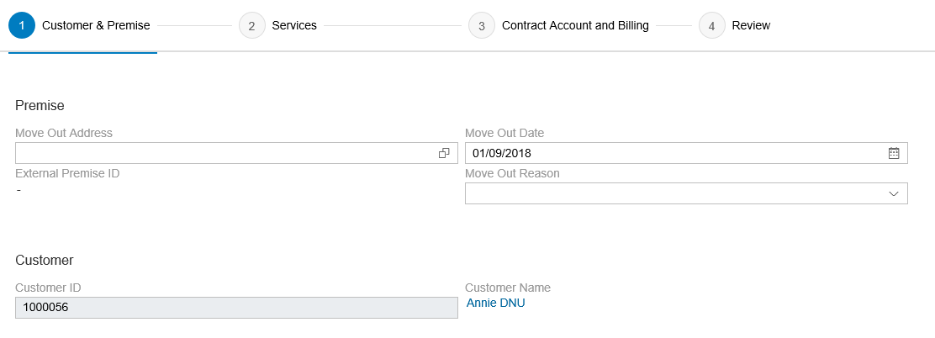

The following data elements will be used by the Move Out – Customer & Premise.
Field | Type | Comments
Move Out Address | Required | Premise for the Move Out location, search and select from drop down option
Move Out Date | Required | Contract end date
Move Out Reason | Required | Move Out reason, select from drop down option
Customer Id | Required | BP number, search and select from drop down option



The following data elements will be used by the Move Out – Services.
Field | Type | Comments
Select Service | Required | Selection checkbox for services (electric, water, gas, residential streetlight)
Installation | Display | Installation # where the service is getting terminated
Division | Display | Type of service (Electricity, Gas, Water etc.)
Rate Category | Display | Rate category for the Service
Remove Meter | Optional | Selection checkbox for meter removal
Create Service Order | Optional | Selection checkbox for RSS enabled Service Request or non-RSS enabled meter Service Order creation.  This checkbox will be hidden
Description | Optional | Description that will be updated to Service Request or Service Order.  This field will be hidden
Meter Reading | Optional | Customer meter read. Not applicable to SCE. This section will be hidden

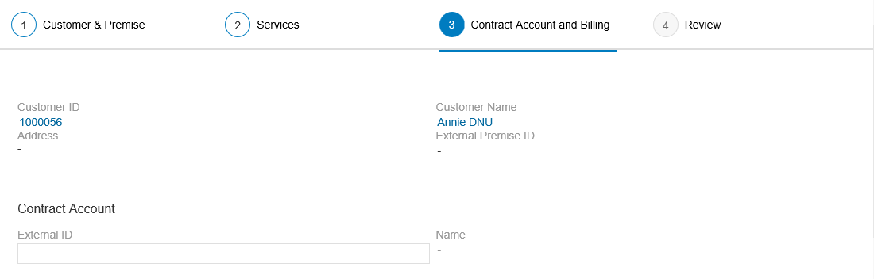

The following data elements will be used by the Move Out – Contract Account and Billing.

Field | Type | Comments
Contract Account External ID | Display | Contract Account number, auto defaulted if CA is selected prior initiating Move Out process
Same as Move Out Address | Display | Mailing address information
Notes – Add new note | Display | Long text field

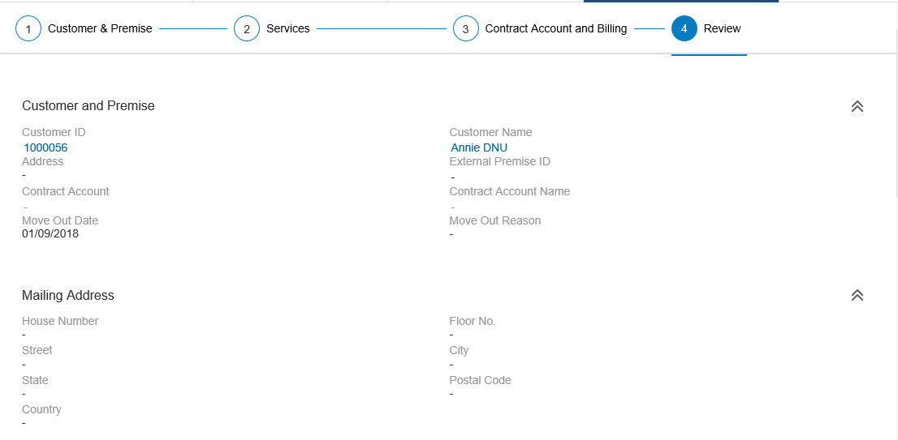

The following data elements will be used by the Move Out – Review.
Field | Type | Comments
Customer and Premise | Display | BP number & name  Premise address  Contract Account number  Move Out date
Mailing Address | Display | Mailing address information
Services | Display | Installation number  Rate Category  Service Order information
Meter Reading | Display | Not applicable to SCE, will be made hidden
Notes | Display | Long text

Move Out Date Change



The following data elements will be used by the Move Out Date Change process.

Field | Type | Comments
Move-Out Date | Required | New Move Out Date

Move Out Reversal


The following data elements will be used by the Move Out Reversal process.
Field | Type | Comments
Yes, No button | Required | Click Yes button to proceed with Move Out reversal.  Click No button to exit Move Out reversal.

Transfer Process

Transfer process consists of six different views and they are in the followings sequence:
- Move Out Premise
- Move Out Services
- Move In Premise
- Move In Services
- Contract Account and Billing
- Review



The following data elements will be used by the Transfer – Move Out Premise.
Field | Type | Comments
Move Out Address | Required | Premise for the Move Out location, search and select from drop down option
Move Out Date | Required | Contract end date
Move Out Reason | Required | Move Out reason, select from drop down option
Customer Id | Required | BP number, search and select from drop down option



The following data elements will be used by the Transfer – Move Out Service.
Field | Type | Comments
Select Service | Required | Selection checkbox for services (electric, water, gas, residential streetlight)
Installation | Display | Installation # where the service is getting terminated
Division | Display | Type of service (Electricity, Gas, Water etc.)
Rate Category | Display | Rate category for the Service
Remove Meter | Optional | Selection checkbox for meter removal
Deleted | Display | Checkbox is checked if Installation is marked deactivated
Create Service Order | Optional | Selection checkbox for RSS enabled Service Request or non-RSS enabled meter Service Order creation. Will be hidden
Description | Optional | Description that will be updated to Service Request or Service Order. Will be hidden
Meter Reading | Optional | Customer meter read. Not applicable to SCE. Will be hidden



The following data elements will be used by the Transfer – Move In Premise.
Field | Type | Comments
Move In Address | Required | Premise for the Move In location, search and select from drop down option
Move In Date | Required | Contract start date
Customer Id | Display | BP number, search and select from drop down option



The following data elements will be used by the Transfer – Move In Services.
Field | Type | Comments
Select Service | Required | Selection checkbox for services (electric, water, gas, residential streetlight)
Installation | Display | Installation # where the service is getting connected to
Division | Display | Type of service (Electricity, Gas, Water etc.)
Rate Category | Required | Rate category for the Move In, select and search from drop down list
ESC Opt Out | Optional | Selection checkbox for Opt Out of Smart meter
Deleted | Display | Checkbox is checked if Installation is marked deactivated
Create Service Order | Optional | Selection checkbox for RSS enabled meter Service Request or non-RSS enabled meter Service Order creation. Will be hidden
Description | Optional | Description that will be updated to Service Request or Service Order. Will be hidden
Meter Reading | Optional | Not applicable to SCE. Will be hidden


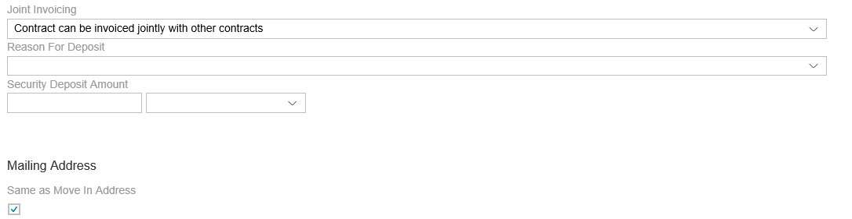

The following data elements will be used by the Transfer – Contract Account and Billing.
Field | Type | Comments
Customer Id | Display | BP number
Customer Name | Display | BP name
Move Out Date | Display | Move Out Date
Move In Date | Display | Move In Date
Move In Address | Display | Move In Address
Move Out Address | Display | Move Out Address
Contract Account External ID | Required | Contract Account number, option to create a new Contract Account
Joint Invoicing | Required | Joint invoicing option, always default to “Contract can be invoiced jointly with other contracts.”
Reason for Deposit | Optional | Search and select from drop down option
Security Deposit Amount | Optional | Security Deposit Amount
Same as Move In Address | Optional | Premise address is defaulted in the mailing address fields if checkbox is selected
Notes – Add new note for Move Out | Optional | Long text field
Notes – Add new note for Move In | Optional | Long text field

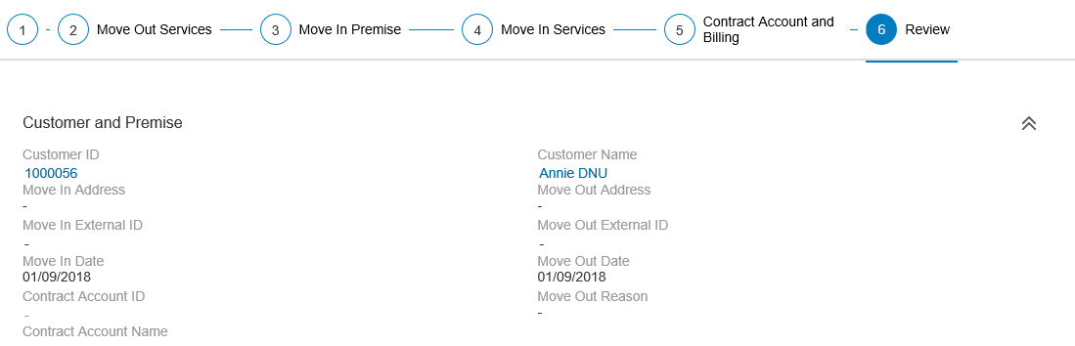
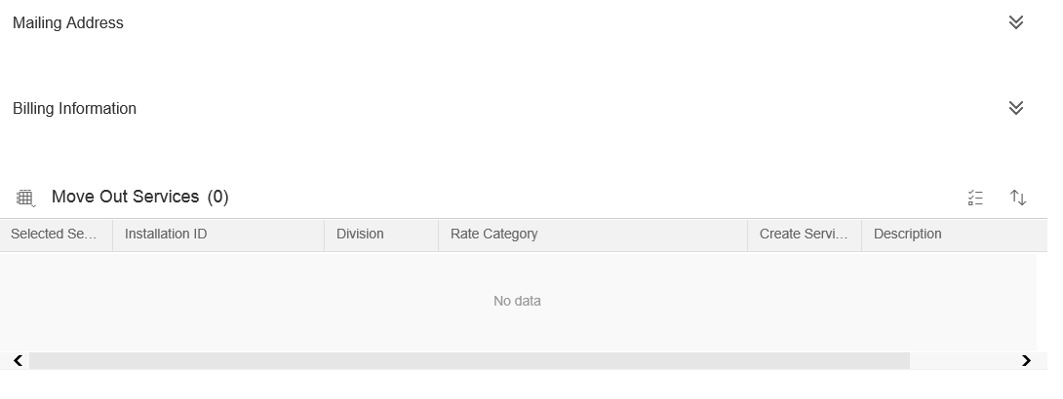
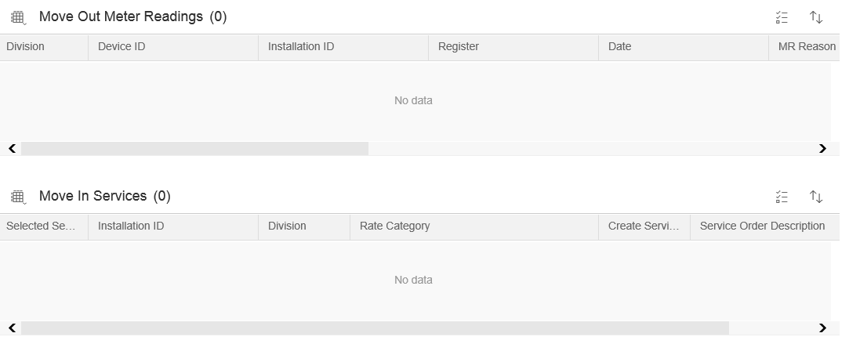
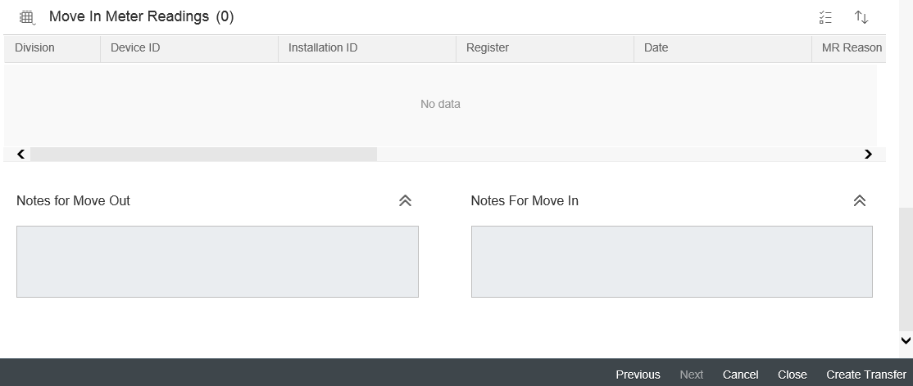
The following data elements will be used by the Transfer – Review. All the information shown are in display mode. This view shows the information that captured during Transfer.
Field | Type | Comments
Customer and Premise | Display | BP #, BP name, Move Out Date, Move Out Date and old and new premise address
Mailing Address | Display | Mailing address entered for Move In
Billing Information | Display | Billing information selected for Move In
Move Out Services | Display | Services selected for Move Out
Move Out Meter Readings | Display | Meter Reading from old premise. Will be hidden
Move In Services | Display | Services selected for Move In
Move In Meter Readings | Display | Meter Reading from new premise. Will be hidden
Notes for Move Out | Display | Long text for Move Out
Notes for Move In | Display | Long text for Move In

Source Systems and Data Volumes
Identify the historical amount, volume, and Southern California Edison source systems for data objects supporting this process.
CATEGORY | 2015 | 2016 | 2017
TOFF | 1,134,186 | 1,113,475 | 1,106,600

Cloud for Customer (Hybris C4C) Integration

Processes
- Identification and search, confirm, create and change BP, Contract Account.
- Search Technical Master Data, search by different parameters on Premise Identification view
- Move Out process
- Move Out Date Change
- Move Out Reversal
- Transfer process

Hybris C4C Views
- BP/Premise Search
- Move Out create
- Move Out Date Change
- Move Out Reversal
- Transfer

Activity Records
- Contract End created
- Contract End Change
- Contract End Reversal
- Transfer created

Exception Management Requirements
This section outlines a high level description of each BPEM Case or other user workflow items (such as “Tickets” used by Front Office) used to route work requests between business areas. The companion document for this section which outlines the detail of each case is documented in APSE on the Exception Case Template General Document #8.
User Exception Scenario / Description | User Group | Initiated by | Work Distribution
Case Category: Move Out – Bill Reversal - If Front Office user wants to complete a Move Out reversal or Move Out Date change. FO user will create this BPEM for RSO to do the bill reversal. | RSO Billing | User | Pull
Case Category: Move Out – Added Facility - The BPEM case is reference to the Contract and BCD Account Executive will document the requested Move Out date as well as caller contact information in the BPEM long text. The BPEM case will be routed to Billing team to work on. T&D will attend to the BPEM case and decide if the Added Facility can be removed from the premise and determine the termination charges | T&D | User | Pull
Case Category: Move Out - Unmetered Streetlight - Move Out includes ending service to unmetered streetlight lighting, RSO Billing to update contract term. | RSO Billing | User | Pull
Case Category: Move Out Adjustment - CCA/DA - A Move Out Date Change for the CCA/DA contract is submitted. RSO will execute the Move Out Date Change. If there is any usage, RSO will do a bill reversal and rebill manually. In addition, RSO will send a maintenance transaction to CCA/DA informing them about the change. | RSO Billing | User | Pull
Case Category: Move Out Reversal - CCA/DA - A Move Out Reversal on a CCA/DA contract. RSO will execute the Move Out Reversal and send a maintenance transaction to CCA/DA informing about the reversal. | RSO Billing | User | Pull
Case Category: Water Restrictor removal - Issue BPEM Case to back office to process “Direct Charge Billing” for Flow Restrictor Removal | RSO Billing | User | Pull
Case Category : NEM Aggregation - A case needs to be issued to back office/Interconnection to verify NEM Aggregation Eligibility (Parcel Contiguity) | NEM Interconnection | User | Pull
Case Category: Self-Certified Sensitive - A case needs to be issued to back office to remove the self-certified sensitive Installation fact after the Move Out completes. | RSO Billing | User | Pull

Process Risks and Mitigation
- If the Move out happens on one day and the Move in is not allowed to be scheduled until the following work day, then there may be a risk of unbilled usage over the time period when no one is responsible for the usage. Mitigation: Use the closing read at Midnight to allow the move out / move in to use the same read eliminating the risk of unbilled usage.
- If a move out is “forced out” by a move in, the current BP may be forced out in error. Mitigation: Confirm the premise for the move in is correct.
- For a non-smart meter move out, if the field personnel is unable to provide a final read, the Move out will be completed with the notation that no final read was obtained. Mitigation: RSO should be alerted on no final read in order to prepare final bill (system does not received final read for move out within 3 days).

Key Performance Indicators
The following have been identified as KPI’s at Southern California Edison, along with the means of measuring each KPI and the current measurement statistic for each KPI:
Measured KPI | Description | Measurement Method | Current Statistic
Move Out | Number of SCE customers lost resulting from a change in address. | Report

Key Metric Definition
The following have been identified as key metrics at Southern California Edison that require business rule for calculation:
Key Metric | Description | Business Rule | Reference
N/A

Controls, Regulatory Rules, and Security
Requirement  ID (from RTM) | “As-Is” Control Requirement | “To Be” Risk Statement | “To-Be” Control Activity” | Control Automation (manual, IT dependent- manual, automated | Relevant technical identifier or RICEFW reference
N/A | N/A | Inappropriate meter device install or calibration may lead to incorrect usage data being processed | At the time of move-in, move-out, or transfer, SAP ISU triggers (1) a Remote Service Switch (RSS) request if installation has a Smart Meter, (2) a Service Order if the installation does not have a Smart Meter or if it consists in a disconnecting or reconnecting of service. | Automated (IT Automated Control) | E-CIM-CS-02
N/A | N/A | Inaccurate or incomplete business master data may lead to bad debt increase or revenue loss | Customer Service Metrics Group provides the error report to Back Office (Revenue Service Organization –RSO and the Customer Billing Operations - CBO) and IT Support groups. Back Office & IT Support groups review the the Master Data Template errors related to create/update business partner, create/update contract account, and residential and non-residential customer move-in/move-out, using transaction ECRMREPL in SAP ISU to ensure no error is blocking the creation/update of the business partner, the contract account or the move-in and move-out document, on a weekly basis (final frequency to be determined). An action plan is detailed in the review for each error older than 2 business days. (Step 150: Contract end date update. (Currently, the As-Is Process is that the IT & RSO groups recevie the individual reports today and the RSO Metric Group PSS&I combines the report into a single report for action by IT & RSO. The Customer Service Metrics Group may be a new group in the future but currently the Customer Service Operations Division - CSOD - Professional Services Support & Integration - PSS&I – group executes the function described in this control). | ITDM | N/A
New | N/A | Inaccurate or incomplete validation process with regard to recognition of business partners and 3rd party information may lead to revenue loss or fraudulent activities. | The front-office user (CCC/BCD Organizations) validates customer information (full customer name, and full address or contract account number or contract number for move-out, and Social Security Number (required for residential), Driver License and Tax ID for Move-out or Update Activity) before processing any action and the request is processed only if requester is the seller or sold-to party business partner, a person who has been defined as authorized by the sold-to-party business partner (e.g. authorized contact relationship to the business partner) or documentation exists for authorizing the requester has been obtained (e.g. business partner becomes deceased and caller is the executor or has a power of attorney for the business partner). | Manual | N/A
New | N/A | Inaccurate or incomplete validation process with regard to recognition of business partners and 3rd party information may lead to revenue loss or fraudulent activities. | The Quality Assurance team (CCC Organization) listens and scores on a monthly basis 5 calls per agent to ensure that Move-In, Move-Out or Update Activity requestors are validated by front office operator. (Validation of full customer name, and full address or contract account number or contract number for move-out, and Social Security Number (required for residential), Driver License and Tax ID) are required for Move-out or Update Activity). The callers are authorized requesters who are seller or sold-to party business partner, a person who has been defined as authorized by the seller or sold-to-party business partner, or requestors with documentation that authorizes the requester. BCD Operations – Data Governance & Data Quality - conducts annual contact certification to ensure communication methods with assigned business contacts are complete and accurate. | ITDM (IT Dependent Manual Control) | N/A
New | N/A | Contract will not be created and appears in the error monitoring queue. | When Installation is marked deleted, the Deleted checkbox will be checked and user will not be able select that Installation for Move In/ Transfer. This will eliminate user mistakenly select the deleted Installation for Move In.  (Step 190 in Transfer process flow) | IT Automated Control | E-CIM-CS-02 - Capture Opt Out, Inspection Required and service fees

Security Considerations

Role | Transaction Code (T-Code) | T-Code Description | Authorization Attributes | SOD Conflicts (Yes/No)  If SOD Conflicts Yes. Identify the 2 conflicting t-codes
Create Move Out | Hybris C4C - Move Out | Hybris C4C Move Out Creation functionality |  | No
Move Out Date Change | Hybris C4C - Move Out Date Change | Hybris C4C Move Out Date Change functionality |  | No
Move Out Reversal | Hybris C4C – Move Out Reversal | Hybris C4C Move Out Reversal functionality |  | No
Transfer | Hybris C4C – Transfer | Hybris C4C Transfer functionality |  | No
Create Move Out, Move Out Date Change, Move Out Reversal, Transfer | Hybris C4C – Display Contract | Hybris C4C Contract Display functionality |  | No
Create Move Out | EC55E | S/4HANA Move Out Creation functionality |  | No
Move Out Date Change | EC56E | S/4HANA Move Out Change functionality |  | No
Move Out Reversal | ES58E | S/4HANA Move Out Reversal functionality |  | No
Transfer | EC70 | S/4HANA functionality |  | No
Create Move Out, Move Out Date Change, Move Out Reversal, Transfer | EC57E | S/4HANA Move Out Display functionality |  | No

Custom Program/Transaction Codes
Please identify any custom programs/transaction codes that need to be developed for RICEFW objects.
- Is the custom program executed in the batch mode or dialogue mode
- Is the custom program assigned to an authorization group
- What is the custom transaction code for the custom program
- Should there be an authorization check made against any field in the custom program/custom t-code and if so what is the custom/standard authorization object used(For example does it have to be restricted to residential vs commercial customer)
- Does the custom programs/custom t-codes have any crictial or sensitive customer information that needs extra security
Custom Program | Authorization Grp | Custom T-code | Authorization Object used in the authorization check statement
N/A

Custom Table/Transaction Codes
Please identify any custom tables/transaction codes that need to be developed for RICEFW objects.
- Are there any customer sensitive/critical Z tables created?
- What is the authorization group assigned to the table?
- Is it just a maintenance or display only table?
- What is the Z transaction code for the custom table?

Custom Table | Authorization Grp Assigned | Custom T-code for the Table | Table Access (display/update)
N/A

Technical Considerations

4.1 RICEF-W Assessment
All of the Forms, Reports, Interfaces, Conversion items, Enhancements and Workflows (RICEF-W) that have been identified for this BPD are detailed in the tables below and will represent the totality of all RICEF-W items documented at the time of sign-off of this BPD. Any RICEF-W items that are identified after this BPD receives final sign-off will only be managed within Southern California Edison’s APSE environment and not within this document.

Reports
Description (include the Business Purpose) | Complexity | Reference ID
Provide the number of turn-offs created by each organization (e.g. CCC, RSO, GC, BCD etc.) and by channel (e.g. Phone, sce.com, IVR, web-chat, etc.) | Complex | REP-CIM-CS-02-1 Number of TUON TUOF by Organization & Channel

Interfaces
Description (include the Business Purpose) | Complexity | Reference ID
N/A

Conversion
Description (include the Business Purpose) | Complexity | Reference ID
Refer to BPD CIM-CS-02 Handle Customer Move In/Out – Contract New for conversion RICEFW item

Enhancements
Description (include the Business Purpose) | Complexity | Reference ID
- Auto reverse for backdated move out, back dated move out change and move out reversal.  - Ability to handle the billing implications of a changed/reversed move out (e.g. if bill needs adjustment) or changed/reversed move out (e.g. rules determine when agent can do the work versus when a case flows thru to back office for handling)  - Ability to automatically reverse out billed and/or paid charges if backdating the turn off  - If user perform a date change on turn off request and final bill is pending, system shall automatically cancel the final bill request and not send it to the BP  - If user perform a date change on turn off request and final bill is sent, system shall automatically reverse the final bill  - If user enter a cancel Move-out request and final bill is pending, system shall automatically cancel the final bill request and not send it to the BP  - If user enter a cancel turn off request and final bill is sent, system shall automatically reverse the final bill  - Ability to select remove meter (device) and service line on move out | Complex | E-CIM-CS-03 - Move Out /Change/Reversal - Invoice Reversal
- Ability to automatically generate a service order to install a smart meter when an "Opt-out" contract is closed (move out) to replace a register read meter  - Ability to create the required type of turn off WO (eg. Turn off with meter removal, removal & service, flow restrictor)  - If turn off is completed, the system shall enable user to update the turn off date to future date and system shall auto issue the turn on work order for the same day to re-energize the premise if power is already off  - If user reverses move out, system shall auto issue a reconnect order to be completed same day if premise power is currently off and required user to enter the access info and read the safety msg before completing the Work Order  - If a user cancels a move-out, the system shall automatically cancel the turn-off order as well if one exists for that move-out  - If TOFF (turn off) and SDP (Summer Discount Program) /SDPO, then the A/C cycling device should automatically be turned off / set idle  - If customer does not acknowledge the safety message, the system shall create a work order (send to Click for scheduling) – regardless of AMI or non-AMI meter  - RSS in-eligible flag. if flagged, Move-In/Move-Out request will not be sent to RSS and a Turn On/Off WO will be created by system | Complex | E-CIM-CS-02 - Create Work Order during Move-In/Move-Out/Transfer
Ability for the system or agent to transfer the deposit from one contract to another.  User to reinstate Deposit back to BP for Move Out Reversal (tcode FPSEC1)  User to enroll BP to eBill (tcode CAA2) | Simple | E-CIM-CS-02 Transaction Launcher
BP has opted out of CCA from the moving out premise and transferring within the same CCA territory, the system will not default the move in with CCA Product (Rate).  BP has opted out of CCA from the moving out premise and transferring to a different CCA territory, the system will default the move in with CCA Product. | Medium | E-CIM-CS-02 - Default CCA rate during Move-In & Transfer
A warning message if the move out date is 12 months in the past of the current date. User is able to proceed. | Simple | ENH-CIM-CS-02-4-2 Move Out Date validation
Ability for system not to default CCA to move in customer when customer transfer within the same CCA territory when the customer has opted out of CCA | Medium | ENH-CIM-CS-02-1-027 - Not to default CCA product for CCA opt out customer
Ability for system to default CCA to move in customer when customer transfer to different CCA territory when the customer has opted out of CCA . | Medium | ENH-CIM-CS-02-1-028 - Default CCA product for transfer to different CCA territory
'If an account has an active MBL or CARE enrollment and requests to transfer service to a new location, the system shall automatically transfer the program to the new contract | Medium | ENH - CIM-CS-02-7-1 Auto transfer CARE & MBL from old premise to new premise
Ability to make the number of days between active service for MBL and CARE auto transfers to the same and configurable. | Medium | ENH- CIM-CS-02-7-1 Time frame for MBL/CARE turn on
Ability to view if an Installation is marked for deletion. Eg. Added Facility. | Medium | E-CIM-CS-02 - Capture Opt Out, Inspection Required and service fees

Forms
Description (include the Business Purpose) | Complexity | Reference ID
Move Out notification from Open Text to BP via preferred channel. | Medium | F-CIM-CS-03 Thank You Notification
Move Out Date change notification from Open Text to BP via preferred channel. | Medium | F-CIM-CS-03 Move Out Date Change Notification
Move Out Reversal notification from Open Text to BP via preferred channel. | Medium | F-CIM-CS-03 Move Out Reversal Notification.

Workflows
Description (include the Business Purpose) | Complexity | Reference ID
Align the Move Out date to the Service Order or RSS Request when there is a Move Out date change | Simple | W-CIM-CS-02 - Align new Move-In date to Service Order  **Changed from E to W

IDEX Considerations
- Upon completion of Move Out, IDEX will interface and provide the data to CCA/DA system for CCA/DA to drop the service from BP
- Upon completion of Move Out data change, IDEX will interface and provide the data to CCA/DA system for change of data
- Upon completion of Move Out reversal, IDEX will interface and provide the data to CCA/DA system to establishment of service to BP
- Upon completion of Transfer, IDEX will interface and provide the data to CCA/DA system to drop and/or establish service to BP

Production System Cut-over Considerations
- Contracts that are marked as deleted or having a move out date that is in the past or equal to system date will not be migrated over.
- Contracts having future dated move out date will be migrated over.

4.4 Other Considerations
N/A

Change Management

5.1 Change Impacts
Change Element Short Description | Change Impact Category | Audience Group(s) | Impact | Business Effort
The naming convention will change in SAP related to turn on/turn off services. Move in is an object vs turn on is a work order to connect the power (e.g. RSS, field turn on) as a result of the move in object. Move out is an object vs a turn off is a work order that disconnects the power as a result of the move out object. Move in/out adjustment is the change of date. Move in/out reversal is equal to move in/out cancellation.  Process Start Stop is equivalent to Transfer in SAP | Process (177) | CS-CSOD-CCC All;  CS-CSOD-RSO All;  CS-BCD-All | Low | Low
Policy discussion regarding the level of access for different relationships and authentication requirements in regards to account activity. As part of the process, the frontline users may require to review relationships with the customer at the time of move in and move out. The relationships may need to be updated based on the conversation. Currently authorized callers can access all information and issue transactions without any differentiation. | Decision Making;  Process;  Culture Shift (465) | CS-CSOD-CCC All;  CS-BCD-All | High | Medium
The user will need to manually reinstate the program if a move out reversal has occurred. An automation requirement is pending which will automatically reinstate the program. Currently enrollment of programs and rates needs to be completed by RSO users. | Process;  Decision Making;  Job Roles (183) | CS-CSOD-CCC All;  CS-CSOD-RSO-BOM;  CS-BCD-All | Medium | Medium
If the end date of the move out is changed or cancelled, the user will need to validate the mailing address. Since the mailing address is stored at the business partner level, it is recommended to validate the mailing address at the business partner screen (outside of the move out object) to verify if there are any impacts to the standard business partner address. If the address is set as "fixed", then the address is specific to that contract account. Currently the mailing address is visible within the turn off window and can be verified without having to access a separate screen because the mailing address is stored at the customer account level and does not impact any other business partner addresses. | Process (748) | CS-BCD-All;  CS-CSOD-CCC All;  CS-CSOD-RSO All;  CS-CSOD-Consumer Affairs | Low | High
Front office users will create BPEM cases for transactions that need to be worked by back office users. BPEM cases will create visibility and traceability to the order that we do not have access today. Currently users will add a note and send an email to the appropriate parties. Users are not able to view if the email was sent properly or the status of the request or when the request was completed. It provides more visibility to front office of the request and can advise customers the status of their requests.  Examples: streetlight requests, water flow restrictor, self certify sensitive | Benefit/Improvement  Culture Shift  Decision Making  Process (782) | CS-BCD-All;  CS-CSOD-CCC All;  CS-CSOD-RSO All;  CS-CSOD-Consumer Affairs | Medium | Low
Users can not cancel a move out request if a New party has a move in pending. They would only be able to change the date up to the new party in's move in request. To cancel the move out request, users will need to cancel the move in for the new party. Currently we are able to cancel the turn off request without having the cancel the new party in. Typically a new party in move in is not cancelled unless we hear from the business partner. | Process; Decision Making (783) | CS-BCD-All; CS-CSOD-CCC All; CS-CSOD-Consumer Affairs; CS-CSOD-RSO All | Low | Low

Below is a description of each:
Change Element Short Description: Describes the ‘As-Is’ scenario and what is changing.
Change Impact Category: Determined by asking the questions below.
- Staffing Levels - Is the work effort increasing or decreasing (staffing levels), and how (e.g., task automation, new process/tasks)?
- Job Roles - Will the responsibilities, authority, or required skills for a job or job roles change? Will people be reporting to new leaders? Will managers’ responsibilities change?
- Compensation / Performance - Will the changes have such an impact on roles of an individual that merits a change in how they are compensated or how their performance will be evaluated? What behaviors are rewarded and recognized?
- Organization Structure - Is the ownership of the Process or Data changing (think departments, jobs, or roles, not individuals)?
- Decision Making - Will any of the changes impact how decisions are made, by or between, business units / departments? Who makes them, how they determine the criteria for making a change?
- Culture Shift - Will organizational value systems impact the way change happens or be impacted by the change? What are the underlying values of the organization that will directly influence the way change will be accepted and how much work will ultimately be required to ensure successful outcomes for the business?
- Location / Facilities - Will the change impact the physical location where they process is being implemented or require changes to the facilities to enable the process to be effective?
- Process - Any change to the current process (e.g. manual process becomes automatic, or vice versa)? Are there new processes being introduced or an old process being decommissioned? Is there a requirement to change an existing business rule or business policy? Will new business rule or policy needs to be introduced and enforced or complied to?
- Regulatory/ Legal - Are there any legal / regulatory requirements that might be impacted
- Technology - Are other applications impacted (e.g., going away, becoming read-only), or are there new requirements (e.g., new SW / HW, new version)
- Benefit/Improvement - Will there be an improvement or benefit to any of the stakeholders because of this change. (Be sure to include any pain points that are being alleviated)
- Other - Are there emotional implications stemming from any of these changes (think of buy-in issues or fears)
Audience Group(s): These are the affected departments, divisions etc…
Impact: The following were used to determine the impact:

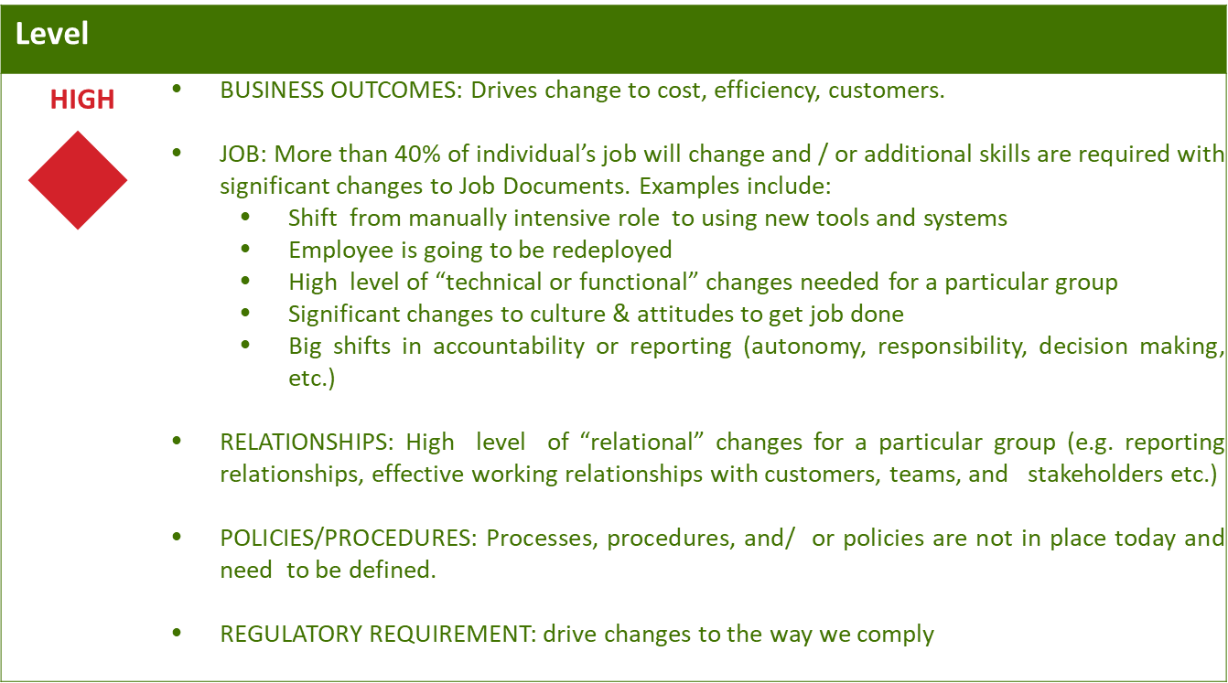
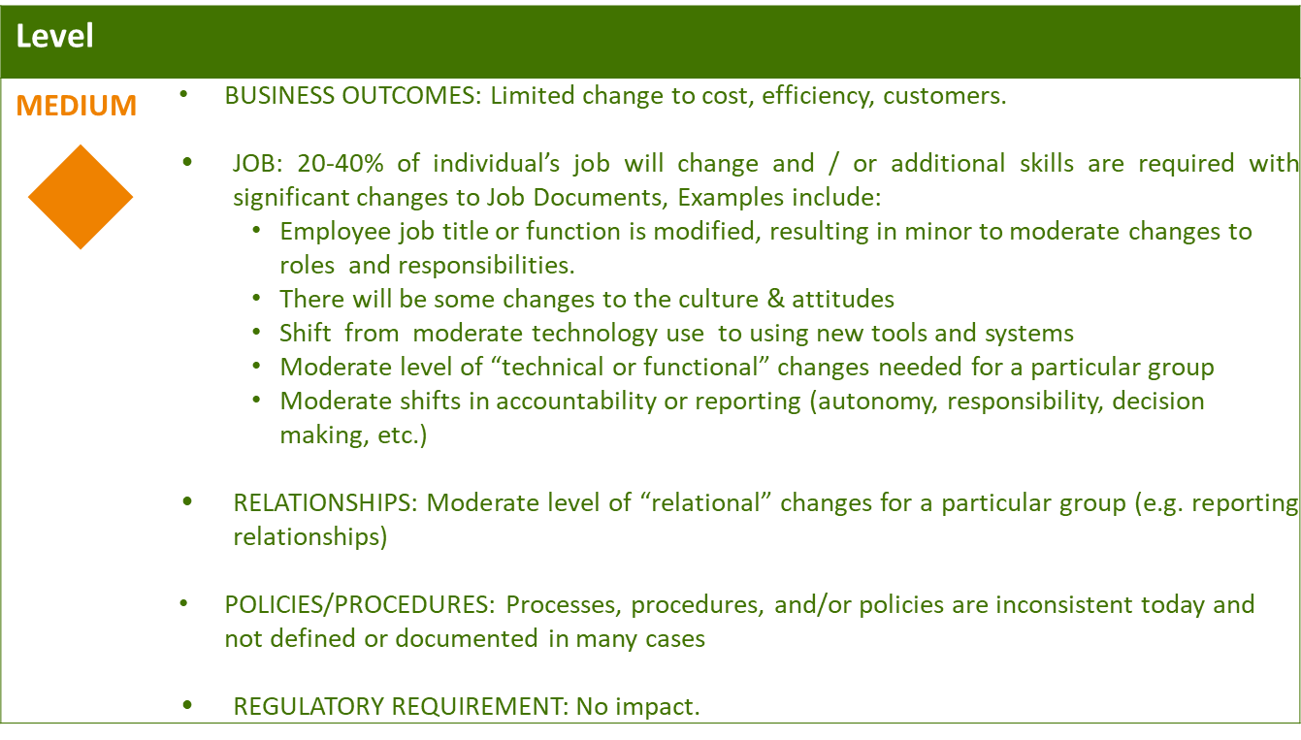
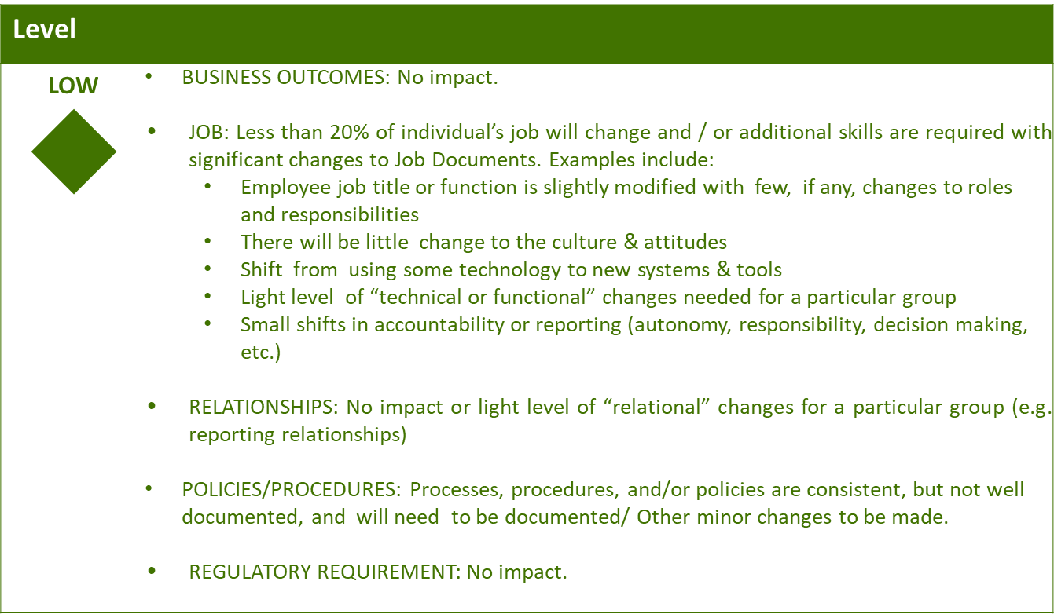

Business Effort: Initial assessment of the impact to the business High, Medium, Low

Requirements
Requirement # | APSE Requirement # | Requirement Description

7. Ticket
Attached is the list of Tickets defined in this BPD.

8. Appendix

Visio Template

